

Microprocessor System Design

8051 System Design

Michael Goberling

5/2/2017

Hamid Sharif-Kashani

TA: Sushanta Mohan Rakshit

# 2.png

Table of Contents

1 Objective 3

2 Background 3

3 Procedure 6

3.1 System Design 6

3.1.1 Mapping and Decoding 6

3.1.2 Reset Circuitry 7

3.2 Schematic Capture 8

3.3 Prototyping 10

3.4 PCB Design 12

4 Source Code Discussion 13

5 Hardware Discussion 18

6 Problems Encountered 20

7 Conclusions 21

7.1 Summary 21

7.2 Future Work 21

8 References 22

9 Appendices 23

9.1 Source Code 23

9.2 Schematic 59

9.3 PCB Design 65

9.3.1 Pictures 66

9.4 Decoding 70

9.4.1 Decoder Logic 70

9.4.2 Decoder Code 72

# Objective

To learn the learn the required steps to design, prototype, and arrange a PCB for a functional 8051 microcontroller system with the following specifications:

* 64K of SRAM (2 chips)
* 64K of EEROM (2 chips)
* A 7-segment display
* A keypad with 16 keys
* A 4x20 LCD
* A Real-Time Clock
* An analog to digital converter with temperature sensor input

# Background

Modeling an 8051 microcontroller system begins with understanding how to utilize system ports and address memory and I/O devices. When using external memory and devices in a microcontroller system, selecting components to communicate with the microcontroller on a bus system in a timely manner is essential to a functional design. Therefore, the first required skill for designing this system is possessing logical analysis abilities to choose decoding addresses for device chip selects or for the device appropriate data latches in a way that will extinguish any possible conflicts on the bus system.

A prominent portion of designing a microcontroller system is performing analysis on the required parts by parsing and mining provided or procured datasheets. Aspects such as package size, pin count, pin description, electrical characteristics, and device initialization are all things to consider when arranging a microcontroller system.

Following theoretical system design, visualization of such a system is necessary for implementation. Visual interpretation can be in the form of description, drawing, or schematic capture. For this system, a system schematic with a hierarchical block diagram was designed. This schematic was modeled with the following in mind: description of the system, theoretical decoding for the system, and electrical requirements for the system.

Procuring a schematic for any given electronic design requires capture software. For the purposes of this project, Autodesk’s schematic capture and PCB design software, EAGLE, was utilized. EAGLE features an intuitive system that allows users to create footprints, packages, and connect those devices with little clutter. The reason for choosing EAGLE was that the net naming convention allows for clean and easy to understand schematics that translate smoothly to PCB designs.

In the event packages or footprints for the design you have theorized are not available to you, knowledge of symbol creation in your chosen software and datasheet analysis abilities are essential to the visualization process.

Upon successful theoretical design and visual interpretation, prototyping such a design is necessary to ensure proper functionality.

For means of implementing decoding, PAL technology was utilized. This means that knowledge of VHDL or Verilog programming and testing, and flashing such chips are required for this system design. Quartus 9.1 was used as a development and testing environment for means of establishing decoding logic and generating VHDL files. ISPLever Project Navigator was used to translate the VHDL file into a JEDEC file. A Dataman and the accompanying software was used to flash the PAL chip with the generated JEDEC file.

Experience in electrical circuit design and analysis are required for optimal testing. Possessing knowledge and ability of the utilization of tools such as logic analyzers, oscilloscopes, and digital multimeters is fundamental to constructing, testing, and ensuring system functionality.

Knowledge of the instruction set and internal memory system for Intel’s 8051 is required for implementing firmware for system functionality. For information regarding the instruction set, *The 8051 Microcontroller: A Systems Approach (Mazidi, Mazidi, Mckinlay)* was referenced.

An intuitive and informative development environment is also optimal for writing assembly language or C firmware for a microcontroller system. For means of developing software for this system, MCU 8051 IDE was utilized. The software features a simulation platform which allows programmers to visualize register values, system flags, and port values. Additionally, the simulator provides port configuration and interaction with devices such as 2x20 LCDs, matrix keypads, LEDs and more. The MCU 8051 IDE environment also includes functionality for quick access of information regarding 8051 instructions such as valid register and flags that may be affected for any given instruction. Due to the simplicity of the design, system software was completed on the fly, with no unit tests performed on individual components. This was due to the timeline required for the project, and the desire to ensure cross-functionality of the components within the design.

Combining hardware design and software design is the quintessential requirement for designing any microcontroller system. It is important to understand that while theoretical hardware design may appear to be functional, it is only when software is applied to a system that realizations of design can truly occur. This is mentioned, because many changes were made to the original hardware design while attempting to prototype and breadboard the system. Decisions on changes were made mostly due to potential bus conflicts. These changes will be further explained in the *Problems Encountered* portion of this report, but for the bulk of the explanation, the final design will be described.

Arranging a PCB when a microcontroller design has been prototyped and approved for functionality is the last portion of design. For means of procuring PCB design files, EAGLE was used. Translating schematic captures to PCB designs in EAGLE is an easy task provided footprints and packages have been determined correctly from the required datasheets. While connecting rats, trace size, signal proximity, and size constraints were considered.

Upon successful PCB generation and ordering, ensuring correct connection of traces via DMM testing is crucial. Once all traces have been verified, soldering the discrete parts, mounting equipment, and chips to the board is the final frontier. Testing board functionality with soldered parts, and developing the remaining software is all that stands between you and a functional microcontroller system design.

# Procedure

## System Design

### Mapping and Decoding

For theorizing system design, methods from the *Microcontroller System Design* course instructed by Hamid Sharif-Kashani were used. Given the system specifications of two chips of 32K RAM and ROM a decision had to be made with how to access 128k of total memory, given the 8051 only has 16 address lines. The decision was made to create separate data memory and program memory maps by including the PSEN line for decoding these chips. When PSEN goes low to access program memory, data memory will not be effects, and vice versa. Additionally, given that all address locations for RAM and ROM would be filled by these chips, P3.0 on the 8051 was delegated as the I/O line to create a third and final memory map for I/O. These memory maps can be found in the *Decoding* section of this report.

Using logical analysis, it was determined that for differentiating between the two memory chips, address line 15 could be used, because between 0000h - 7FFFh and 8000h - FFFFh only address line 15 does not change for either chip in the RAM or ROM memory map.

Using an I/O pin in the design allowed for the choice of any combination of non-conflicting address lines to be utilized for I/O device decoding, without need for RAM or ROM address consideration. For simplicity, the design features four address lines -- one per device. The address map featuring the relevant signals for decoding can be in the *Decoding* portion of this report.

Writing code for decoding involved developing a VHDL program with pin declarations that could be used within the system. Knowing that the PAL chip provided had 22 available pins for input or output, the pin declarations were the first order of business. The pin declarations are shown below, and can be verified by looking at the code in the *Decoding Code* section of this report. Red signifies input signal while blue signifies an output signal. The WR line was initially intended to be used in the decoding, but was eventually decided to be unnecessary. This will be covered in the *Problems Encountered* section of this report. Further software discussion can be found in the *Software Discussion* section of this report. The pin declarations for the PAL chip can be found in the *Decoding* section of this report.

### Reset Circuitry

Three components were required for designing the reset circuit of the 8051 chip: A switch button, capacitor, and a resistor. Small consideration was given in terms of the timing of the capacitor-resistor circuit given that the reset pin only needs to be high for two machine cycles before the microcontroller can detect a reset, and given that the supplied parts only featured a small amount of different types of discrete capacitors and resistors.

Calculations were performed to determine the minimum time required for the reset line to be driven low for a successful system reset given a 12MHz clock. First, a single period was determined.

With the value for one oscillator period, the amount of time needed for one machine cycle to complete could be calculated

With the value for one machine cycle calculated, take this by 2 to get the amount of time required for the reset pin to be low

With the time required for the reset pin to be low, the minimum required capacitor value given a 10kΩ resistor was calculated.

Given the previous calculation, a 10uF capacitor was chosen to be paired with the 10kΩ resistor for use in the reset circuitry. This gave the processor plenty of time to take in the reset pin given a switch button press.

## Schematic Capture

Now, with the ability to select which device could be active on the bus system at any given time in software, and the reset circuitry for the 8051 determined, the schematic was designed using EAGLE. Using a hierarchical block and module system, a page was created for the main schematic that would house each device module. Meanwhile additional schematic pages for the modules were created for capturing each device including the oscillator and power components. Special consideration was made to ensure that the power connection was above the ground connection for clarity. These schematic pages can be found at the end of this report in the *Schematic* section.

The symbol and footprint used for capacitors in schematic capture were C-US, while the symbol and footprint used for resistors in schematic capture were R-US_.

The 8051 symbol for the schematic and footprint for the PCB was taken from the EAGLE libraries as part number AT89C51-24PC. The pins were checked as correct using the provided datasheet for the AT89C55WD. Port 1 connected to the keypad, P3.0 connected to the PAL, P3.1 connected to R/W on the LCD, P3.2 connected to RS on the LCD, and the rest of the Port 3 pins left no connect. /WR and /RD were connected to ROM, RAM, the ADC, RTC, and PAL accordingly.

The symbols and footprints used for ROM and RAM were taken from a library created by Collin MD Peterson, and are part number AT28C256. The footprints for ROM were edited to accompany ZIF sockets for easy access of ROM. The address and data bus were connected accordingly to these chips. For ROM, /WE was connected to VCC, and /OE was connected to /PSEN. For RAM, /WE was connected to /WR, and /OE was connected to /RD. XTAL1 was connected to the clock circuitry. RST was connected to the reset circuitry.

The symbol and footprint used for the reset switch were taken from the EAGLE libraries as part number SW-SPST-TACT-4.

The symbol and footprint used for the clock oscillator was taken from a library created by Collin MD Peterson, and is part number ECS-2200. OUT was connected to XTAL1 on the 8051.

The symbol and footprint used for the DC power jack was taken from the EAGLE libraries as part number JACK-PLUG.

The symbol and footprint used for all data latches was taken from the EAGLE libraries as part number 74HCT573N. The latch was connected to the data bus accordingly, and the output of the latch connected to the required device.

The symbol and footprint used for the seven-segment display was taken from the EAGLE libraries as part number 7-SEG-SA52-11.

The symbol and footprint used for the keypad was taken from a library created by Collin MD Peterson, and is part number AK-1604-N-BWB. Columns 1-4 were connected to port 1 pins 0-3, and Rows 1-4 were connected to port 1 pins 4-7.

The symbol and footprint used for the PAL device was taken from the EAGLE libraries as part number GAL22V10D-7LPN. Pin declarations have been outlined in the *Decoding* section of this report.

The symbol and footprint used for the LCD was taken from a library created by Collin MD Peterson, and is part number WH2004A-CFH-JT. It was decided that the LCD did not need a data latch due to its internal Enable line. R/W was connected to P3.1, and RS was connected to P3.2.

The symbols and footprints for the temperature sensor and ADC were taken from a library created by Collin MD Peterson, and are part numbers TMP36 and TLC0820AC-N. /RD was connected to /RD on the 8051 with the data lines of the ADC connected to the data bus.

Modules were created for the reset circuitry, clock circuitry, power circuitry, all RAM and ROM chips, the seven-segment display, the keypad, decoding circuitry, temperature sensing circuitry, and the RTC.

Pins do not physically need to be connected on the schematic in EAGLE. When a new net is created, a name is required for it. If two names match up, they are connected in the netlist. All devices excluding the keypad were connected via net declarations to the data bus of the 8051. The keypad was connected to port 1 of the 8051 for ease of programming and so that a data latch did not need to be used. Chip selects, and other control signals were connected to devices accordingly and net names created accordingly. Finally, VCC and GND connections were confirmed for each module and device.

## Prototyping

For testing connection between two chips on the board, a DMM was used in audible mode by touching one terminal to one pin, and the other terminal to the other checked pin. Sound would be made if there was a connection due to the small resistances in wires. For testing signals within the system while debugging, the Saleae Pro 16 Channel logic analyzer was used along with the accompanying software.

Prior to constructing circuitry, power and ground were applied to the 8051 chip and the ALE pin was analyzed using an oscilloscope to ensure that the microcontroller was functional. Additionally, power and ground were applied to the clock oscillator and to ensure that oscillation was occurring accordingly using an oscilloscope. As a final precaution to using the 8051, the reset circuitry was tested and the clock analyzed to ensure that a proper system reset was taking place.

Following confirmation that the microcontroller, clock component, and reset circuitry were functional, all components were placed on the board in succession of testing with writing, spatial sensitivity, and proximity in mind. Spatial sensitivity was account for while placing the temperature sensor and oscillator. Proximity was considered especially for placing the memory chips and the microcontroller so that long wires were not required as noise can cause various issues with electronic circuits.

First, the 8051 was placed in the top middle of the board, with the memory chips right above it, and the address latch just to the side. The data bus and ALE were connected to the address latch, and the output of the address latch connected to one memory chip, and each successive memory chip connected to the data bus of that memory chip. The same was accomplished for the upper eight bits of the address bus minus the address latch. The data bus of the microcontroller was connected to one chip as well, and broken out to each successive memory chip. Each bus connection was then checked using the DMM.

Following bus connection, the programmed PAL was then placed on the board, while signals were connected in the order outlined in the *Decoding* section of this report. Each address line, control signal, and chip select line was then checked using the DMM.

After the 8051, memory chips, and PAL chip were placed on the board, the seven-segment display and its data latch were connected to the data bus, and chip select for the seven-segment. Simple software was written to ensure the latch and connections were working correctly by blinking the decimal point of the seven-segment display. This code is further discussed in the *Software Discussion* portion of this report.

After confirming that interfacing with the seven-segment was functional, the LCD was connected to the circuit and its appropriate signals. The LCD was connected this early, because it would be impossible to test the RTC and ADC without it. First, the power connections were tested, and code was written to initialize the LCD using the datasheet provided. Diagnosing issues with the LCD took a large portion of time due to electrical problems. These considerations will be discussed in the *Problems Encountered* portion of this report.

With the LCD interfacing, the keypad was set up on port 1 of the 8051, and subsequently a subroutine from *The 8051 Microcontroller: A Systems Approach* (Mazidi, Mazidi, Mckinlay) was used to get a byte in ascii of the key press into the accumulator. This code can be found in the *Source Code* section under the subroutine *PROMPTKEYPAD* or the modified subroutine *POLLKEYPAD.* Reference to book in the *References* section.

Following keypad integration, the RTC and ADC with sensor were connected to the system and subsequently tested using developed code. For the RTC, all registers we set to zero upon wakeup of the system, and subsequently read in a loop. The same was applied to the ADC, only no initial registers were required to be set for the ADC.

With functionality of all components tested and debugged, the system, its decoding, and all electrical considerations proved to be sufficient for the design requirements. Software was developed for the system on the fly for testing. No unit tests were developed for specific components. Because the parts need to all work together for the final design, no benefit was seen from skipping around writing the firmware from the beginning.

## PCB Design

The PCB design files were generated using Autodesk’s EAGLE. With the schematic completed, and all footprints created or procured, part placement began. Pad sizes were analyzed and confirmed for each part and each datasheet. A square of 9in. x 9in. was drawn for the board initially to provide enough space for all components, to minimize the possibility of electrical issues, and because no casing or design restraints were placed on the size of the board.

Power traces were made .05 in. thick to accommodate how important those signals are. The output of the clock trace was made .032 in. thick to accommodate the importance of that signal as well. Finally, all other traces were made .012 in. thick for spatial reasons.

To begin, power components were set in the top left, so that power is applied at the top left of the board as it made organizational sense. For clarity and organization, the top copper layer of traces flow in a vertical fashion, while the bottom copper layer of traces flow in a horizontal fashion.

The 8051 is placed on the left side of the board, and all subsequent memory devices placed to the right of the controller continuing the flow of the board from top left to bottom right.

The LCD and matrix keypad were placed on the bottom left and bottom right portion of the board respectfully, so that the components were out of the way of the rest of the circuit. Outlines were added for these parts so that, again, they were out of the way of other components.

The temperature sensor was placed at the top of the board so that it was out of the way of any sort of electrical interference.

The clock oscillator was placed away from the temperature sensor and close to the microcontroller for the same interference reasons.

The drill files were generated using a CAM Processor job file acquired from SparkFun. This job generated the top copper, bottom copper, top silk, bottom silk, top soldermask, bottom soldermask, and drill files. The manufacturer used was Bay Area Circuits, because I had good experience with them. The final PCB design can be found in the *Appendix* of this report.

# Source Code Discussion

Software design was centered around assembly language using the 8051 instruction set. As mentioned in the *Background* portion of this report, MCU 8051 IDE was used for development and testing of system source code due to its useful simulation features, which provide clarity in terms of internal memory allocation and system flag statuses.

For baseline knowledge, to get the desired values onto the address and data bus, the instruction MOVX is used. Often, the indirect addressing value is used with the DPTR register to get a 16-bit wide address onto the address bus, or with R0 to get an 8-bit address onto the address bus. This is primarily used to achieve a proper chip select for a specific device prior to loading a value onto the data bus with whatever is in A.

An iterative delay system was conceived and tested for timing using the MCU 8051 IDE simulator. A simple 1ms delay was written, called, DELAY_1MS so that other time delays could be implemented. This function simply uses two loops with two registers evaluated using the DJNZ instruction to eat up exactly 1ms. Every other delay written simply called the DELAY_1MS function an iterative amount of times relative to the desired length of the delay. This function is useful in LCD initialization and various message displaying applications for clarity on the LCD.

For sending commands to the LCD module, a function COMNWRT was written. This subroutine simply takes the command previous in A before the call, clears the RS and RW lines on the LCD to signal a command is about to be sent to the module, and then puts the address of the LCD and the accompanying data on the bus system. This subroutine is accompanied by a small 1ms delay to ensure functionality.

The LCD is first initialized using a subroutine called LCD_INIT. This subroutine was taken from the datasheet for the LCD and works by waiting for 50ms, and successively sending commands to the LCD using the previously explained subroutine to accomplish setting the function set to 8-bit, 2-line, and 5x8 dots using 38h, setting the display to on using 0Ch, setting the DDRAM address to 00h to start, and finally setting the display to normal US cursor printing using 06h.

For printing strings and characters to the LCD, two functions PRINTCHAR, and PRINTSTRING, were taken from a previous *Assembly Language Programming* course. PRINTSTRING will take the string pointed at by the DPTR before the call and print it by iteratively calling PRINTCHAR. PRINTCHAR prints the character currently in A to the LCD by loading the address for the LCD into R0, setting the I/O line high, and moving the address onto the address bus, and the character onto the data bus. PRINTSTRING iteratively calls PRINTCHAR until a zero is detected at the data pointer. Hence, all strings end with \0 to signify that a string declaration has ended.

Subroutines were written with the DDRAM addresses of the desired locations in mind on the LCD. Because overflow on the 4x20 LCD goes from line 1 to line 3, this was required. Additionally, to print the temperature in the top right, the command was calculated and pin-pointed to fit right with no character spaces left to the right. These functions work by taking the DDRAM addresses of each character location on the datasheet and setting the 8th bit high to signify a set DDRAM command to the LCD.

For keypad interfacing, PROMPTKEYPAD and POLLKEYPAD were written. Taken from the book *The 8051 Microcontroller: A Systems Approach,* the two subroutines monitor port 1 until one of the row lines has gone low. The subroutine then grounds each column to check for a matched value in a LUT placed at the end of the program. The difference between PROMPT and POLL is that the prompt function will wait for a keypress, while the POLL function will continue out of the subroutine if no change on the keypad is detected.

Since acquiring a byte of information at a time is incredibly important throughout this project, a subroutine called GETBYTE was written to obtain a packed BCD byte from the user where the top nibble is the first keypress entered, and the bottom nibble is the second keypress entered. This subroutine uses ascii detection to see if the value is a number of a character, and converts it into a single hex value depending on the keypress by using bit-masking.

Another important aspect of the source code is overflow and underflow checking. Because the subroutines that use two byte inputs from the user obtain these by storing two bytes in two separate registers, whenever a decrement of increment is performed in the software, overflow or underflow detection is implemented by checking the lower byte. 00h is checked for incrementing as all incrementing is done before checking, and if the lower byte is every 00h, that means that it WAS FFh. If this decision is found, the higher byte associated with that lower byte is incremented. The same is true for decrementing, only instead of 00h being checked, it is FFh that is checked. This is due to the fact that if a lower byte value was 00h and it was decremented, it would be FFh. A value coming into a subroutine can never be FFh and be mis-checked, because pre-decrementing takes place in all parts of the firmware. When this is detected, the program decrements the higher byte associated with that lower byte as well.

For security purposes, users are first requested to press one to login. Once a user has pressed one, they are prompted to enter a 4-digit passcode allocated to them by myself, with three correct tries allowed. The software then accepts four nibbles as keypresses in the form of ascii characters and saves the high byte into R1 and R2, and saves the low byte into R3 and R0. The system then decides if the passcode is a stored LUT at the end of the software. The way the LUT table works is that the high and low bytes are stored in succession, and checked using the zero flag on the accumulator. The passwords are stored in succession, and therefore each password has a verifiable profile, dependent on how far into the LUT the software goes. This profile is stored in R5, and this register is incremented each time a password is checked. This register is used for profile identification later. If it is, then the user is granted access. If it is not, then the user is required to enter in another password, and the number of tries is decreased, which is stored in R6. If the number of tries reaches 0, then the software jumps to LOCKOUT, which simply runs in a loop until power is taken from the system. Once the user gains access the subroutine jumps to CHECKPROFILE, where it checks the value of R5, and prints a welcome message to the accompanying profile. They can now access the main portion of the code.

This software also features a confirmation message each time a two byte value is entered into the system. This was implemented by using the CJNE instruction to check for ‘A’ to submit the value, or ‘D’ to redo the submission. If A is pressed, the program proceeds, otherwise if D is pressed, the program returns to the prior PROMPTKEY call, and restarts the submission process.

The software is built on a looping main subroutine called MONITOR or, depending on the condition of the software MONITORMENU. This subroutine calls other subroutines to get the temperature, print the temperature, and to get and print the values in the RTC. Additionally, this subroutine calls the POLLKEYPAD subroutine, which grabs a keypress from the user in the form of the ascii byte of the key they pressed. The software then uses the CJNE instruction with A to compare the options of B for move, E for edit, F for find, D for dump, or 1 for logging the user out in their ascii forms. If no accepted key is pressed, the program loops back to keep monitoring the status of the RTC and ADC.

A simple function to test the seven-segment display was written called WAKEUP. This subroutine moves the address of the seven-segment data latch to R0, moves the value for blinking the decimal point into A, then moves that information to the address and data bus. The program completes this cycle of flashing the decimal point three times before returning to the main subroutine.

The RTC is initialized at each login through a subroutine called RTC_INIT. This subroutine was taken from the RTC datasheet provided to the class, and works by setting all internal seconds, minutes, and hours registers to 0 by sending their addresses onto the address bus, and 00h onto the data bus, and then starting the count by sending 00h to 4Fh, and sending 00h to 4Dh.

GETTEMP simply loads the address of the ADC into R0, then moves the value on the data bus into A using the MOVX instruction. GETRTC functions similarly, but instead also prints the value of each register by converting it to ascii and then calling PRINTCHAR.

HEXTOASCII converts the HEX value obtained from GETTEMP into three separate ascii values stored in R7, R6, and R5 in order of top digit to bottom digit if looking at the temperature “100”.

PRINTTEMP sets the LCD to the desired DDRAM location on the LCD, and then prints the ascii values obtained from HEXTOASCII in succession. A degree symbol is printed after by sending D8h to the LCD, and then a capital F with 45h.

PROMPTMOVE, PROMPTDUMP, PROMPTEDIT, and PROMPTFIND will print strings to prompt the user to enter the source, block size, and destination required for the relevant subroutine. All of these subroutines take advantage of the GETBYTE subroutine, and subsequently store 16-bit values in two 8-bit registers for later use in the subroutines.

MOVE will take the values entered in PROMPTMOVE, and move the amount of block size from the source address to the destination address in external memory. Because this subroutine uses two bytes in the form of two single byte addresses, it performs overflow detection for those registers for incrementing or decrementing. The software continues to move values while incrementing the source and destination address and decrementing the block size until the block size is zero.

DUMP will take the values for source and block size form PROMPTDUMP and display the memory dump of that location for the duration of the block size. This program is the most memory intensive as it utilizes every possible general purpose register the 8051 offers. R2 and R3 represent the block size, R4 and R5 represent the current address, R0 tracks the number printed to a line, because the 4x20 LCD does no overflow lines in an appropriate manner, R6 tracks the current page number, R7 tracks the amount printed to the LCD, and R1 is a temporary register used for printing a packed BCD value to the LCD. Because the block size cannot be zero, dump works by initially printing the location entered by the user, then incrementing the low byte of the data pointer each time a print is successful. The number of bytes printed to a line is then checked, if it is not 6, then the program continues printing, otherwise it jumps to the second line. For formatting purposes, the LCD can only print 12 bytes at a time to the display. For this reason, the second conditional is to see if the LCD is full, and if it is, to see what the user wants to do. If either the LCD is full, or the block size has been reached, the program jumps to DONE, where the user is prompted with a decision to ‘2’ Exit the program and return to main, ‘0’ continue to the next page, or ‘1’ to go to the previous page. To continue to the next page, the user must have block size left to print. The program checks the higher and lower bytes of the block size to see if there is anything left. If there is, then the program simply jumps back to print, because the next address was pre-incremented, and the page number is incremented. If there is not, the program does not accept the key press, and instead jumps back for another keypress. If the user decides to go to the previous page, the page number is then checked. If it is zero, the keypress is invalid, and the program jumps back to get another keypress, if it is not zero, then the amount printed to the LCD currently, and 12 are subtracted from the address with underflow detection, and the program returns to print.

EDIT takes the starting location entered by the user in the form of two bytes, and prompts the user to replace the byte at that location in external memory. Using GETBYTE, the user enters a byte to the keypad, and then the value is then moved into external memory using MOVX. After the byte has been entered, the location is updated, the new value displayed at the location, and the user is prompted to ‘1’ exit the program, or ‘0’ continue to the next address to edit that byte.

FIND takes the starting location entered by the user in the form of two bytes and takes the block size entered by the user in the form of two bytes, and takes in a single byte to check memory against. The subroutine checks external memory for the entered byte value by loading the value at the current address into A, and subtracting is with the stored entered byte value. Using JZ, we can see if the accumulator is zero. If it is not, the values do not match, and the program continues, otherwise, the value is found, the subroutine prints that the byte was found, and then prints the location the byte was found at. If the value is not found, the subroutine continuously checks until the block size has run out from decrementing. The address checked is incremented at the end of each check as well.

# Hardware Discussion

**Note:** Hardware has been explained thoroughly throughout the *Prototyping*, *Schematic*, and *Background* stages of this report.

The generated PCB is a 9 in. x 9 in. board. The system runs on a 5V DC input from the AC converter coupled with a DC jack supplied with the project. A switch determines the flow of power at the beginning of the circuit. Upwards, and power is on - downwards, and power is off. A fuse is placed shortly after the switch for surge protection at a small scale. Decoupling capacitors are placed at the ground and VCC connections of each component to ensure decoupling of AC signal. A capacitor has been placed across the GND and OUT terminals of the temperature sensor to ensure a smooth reading.

The designed system features the 8-bit 12MHz AT89C55WD Intel 8051 microcontroller, and 64k of ROM and RAM accessed externally. The decoding for these chips has been laid out in the *Decoding* section at the end of this report. The 8051 features eight general purpose 8-bit registers R0-R7, a single 16-bit register DPTR (split into two 8-bit registers DPH and DPL), and four 8-bit ports, with only Port 1 totally accessible without any other signals attached to it. An address latch was connected to the multiplexed AD0-AD7 to generate address lines in line with the pulse of the ALE signal of the 8051, which pulses high at the beginning of each machine cycle. XTAL1 is connected to the oscillator output for clock generating purposes. RST is connected to the output of the reset circuitry for reset purposes. EA/VPP is tied low, because external memory access is taking place. P3.0 is used for I/O decoding, P3.1 is connected to R/W on the LCD, P3.2 is connected to RS on the LCD, P3.3-P3.5 are not used, /RD and /WR are connected to memory, the ADC, and RTC to ensure proper writing and reading from those components.

Each ROM and RAM chip requires 15 address lines to access the full extent of memory within. Likewise, to access these locations 8-bit registers were repurposed within the software development of this system to obtain multiple 16-bit values. For RAM /OE is connected to /RD, /WE is connected to /WR. For ROM, /OE is connected to /PSEN, and /WE is connected to VCC, because writing to ROM is never a good idea while the system is on. Each chip select is connected to the chip select outputs on the PAL.

The PAL decoding chip was programmed using Quartus 9.1 to generate VHDL files, ISPLever Project Navigator to convert those VHDL files into JEDEC files, and a Dataman and its accompanying software to flash the PAL chip. Pin Declarations can be found in the *Decoding* section of this report.

The LCD module is a 4x20 80-character display module with backlight coloring and character opacity via a potentiometer. The backlight is blue by pulling the B pin to ground. The RS line determines if data or command registers are being selected, and the R/W line determines if the software is reading from or writing to the LCD module. The Enable line is connected to the chip select of the LCD on the PAL.

The 4x4 matrix keypad is connected to Port 1 as the sole device on this port. Columns 1-4 are connected to P0-P3 on Port 1, and Rows 1-4 are connected to P4-P7 on Port 1. This keypad can generate characters between 0-F by using software to pull down and check each column.

The ADC is a TLC0820AC-N, an 8-bit resolution analog to digital converter that has an ANLG_IN connection to the temperature sensor, 8 bits of data to the data bus, and a /RD line connected to the /RD line of the 8051. Chip select is connected to the chip select on the PAL.

The RTC is an Epson RTC72421 with registers for seconds, minutes, and hours. The ALE pin of the RTC is connected to the ALE pin of the microcontroller. Address lines zero through three are connected to address lines zero through three on the microcontroller. /RD is connected to /RD on the microcontroller, /WR is connected to /WR on the microcontroller, and the 4-bit RTC output is connected to the data bus. Chip select is connected to the chip select on the PAL.

# Problems Encountered

Problems were chiefly encountered during the prototyping stage of this design. The most prominent problem was an electrical problem regarding the first potentiometer connected to the LCD module. Software solutions were implemented time after time for initialization of the LCD, but to no avail. All connections were checked and verified, and the problem persisted. Eventually, the potentiometer was checked for resistance range, and was stuck at its highest available resistance. This was checked with a DMM. The theory is that the drop across the potentiometer was too large for the voltage range to be met for the LCD module. After the potentiometer was replaced, the LCD module displayed the test string used at the time, and the system functioned.

In the PCB design stage, following the soldering of parts to the board, there was a time where the LCD was displaying unintelligible characters. Having experience with checking the connections on each chip throughout the project, a DMM was used to check each connection. It was found that address line 12 on the first ROM chip was not connected to the microcontroller appropriately via a bad solder joint. The solder joint was quickly fixed, and the system worked just as it had before.

Mid-project, the data bus and port 1 configuration was changed to the current state. Originally, all devices were on port 1, and all devices had a data latch before them to make them into ports. After running into bus conflicts by trying to make the keypad work on a data latch, the switch was made mid-semester to put all devices beside the keypad on the data bus.

Mid-project, the PCB design and schematic capture software was switched from ORCAD Capture and PCB Design to Autodesk’s EAGLE. This switch was made because I could not be in the lab for spring break and shortly thereafter, and due to monetary constraints, could not purchase ORCAD’s software out of pocket. EAGLE is available to students for free, and thus I quickly downloaded it, and began transferring my work from ORCAD to EAGLE as quickly as possible. It proved to be the better decision, because EAGLE has easier net-naming and netlist generation as netlist generation happens on the fly as soon as a new net is named, and thus the translation from schematic to PCB design was accomplished much quicker.

# Conclusions

## Summary

In conclusion, the steps required to design, prototype, and arrange a PCB design for an Intel 8051 microcontroller system given the requirements outlined in the *Objectives* section of this report have been learned and completed. All hardware is functional and integrates with the written software accordingly. All objectives have been met as all devices are interfaced with at one point or another through the operating system’s run-time. Engineering practices have been used to test, prototype, and design the board by way of time planning, using logic to develop decoding for each device, and by asking questions in a timely manner to instructors and peers.

## Future Work

Future PCB designs will be much smaller in size. The spacing consideration for this design were due to the time constraints of the semester, and to ensure the functionality of hardware so that software could be developed and my programming skills could be displayed.

Completing the computer and electronics related work early would provide a time window where I could focus on the mechanical aspects of the build. Currently, the build is an exposed PCB, which is not appealing. I would like to be able to focus on a device case, device carrying case, or extensive mounting equipment for the keypad and LCD.

Towards the beginning of the project, I was wary of asking questions to those around me and my instructors, which led to taking care of some of my problems taking longer than they should have. In the future, I will be more diligent about asking for help in areas that I need it, and of course returning the favor to those who are in need as well.

# References

Mazidi, M. A., Mazidi, J. G., & McKinlay, R. D. (2013). *The 8051 microcontroller: a systems approach*. Boston: Pearson.

Datasheets supplied via BlackBoard by instructors for:

* *Intel 8051 (AT89C55WD)*
* *ECS-2200*
* *RAM and ROM*
* *Seven Segment Display*
* *74HCT573N (data latch)*
* *AK-1604-N-BWB (matrix keypad)*
* *PAL22V10 (decoder chip)*
* *WH2004A-CFH-JT(4x20 LCD)*
* *TLC0820AC-N (analog to digital converter)*
* *TMP36 (temperature sensor)*

# Appendices

## Source Code

;********************************************

;*Author: Michael Goberling *

;*Course: 4330 Microprocessor Design *

;*Assignment: 8051 Source Code *

;*Due date: 5/2/17 *

;*Revision: 1.4 *

;********************************************

org 0h

sjmp start

;========================================================

;| Data equates |

;========================================================

io_temp EQU 10h

io_sevenseg EQU 20h

io_rtc EQU 40h

io_lcd EQU 80h

lcd_clear equ 00000001b

lcd_home equ 00000010b

lcd_fn_set equ 00111100b

lcd_onoff_cntl equ 00001111b

lcd_entry_set equ 00000110b

lcd_ddram equ 10000001b

RS EQU P3.2

RW EQU P3.1

keypad EQU P1

;================================================================================

;| Start of the program |

;================================================================================

start:

LCALL LCD_INIT ;LCD initialization

MOV R0, #IO_SEVENSEG ;clear 7 segment

MOV A, #11111111B

LCALL IOTOGGLE

LCALL wakeUp ;7 segment initialization(3 decimal place blinks)

relogin: LCALL login ;waits for a user to press 1 to continue

LCALL getPasscode ;user enters passcode that allows them access

LCALL RTC_INIT ;initialize the RTC so that login time is kept

monitormenu: LCALL displayMenu ;Display menu options

monitor:

;LCALL flash7seg ;quickly flash status of 7 segment

LCALL getTemp ;temperature in A now

LCALL getRTC ;update time by reading RTC regs

LCALL hexToAscii

LCALL printTemp ;print values in R6 and R7 to LCD

;42h = move

;44h = dump

;45h = edit

;46h = find

LCALL pollKeypad

CJNE A, #42H, compare1 ;check for move, or 'B'

LCALL CLEAR_LCD ;if found, clear lcd

MOV DPTR, #test1 ;print selection string

LCALL printString

LCALL halfseconddelay ;leave it up for some time

LCALL CLEAR_LCD ;clear lcd for entering menu

LCALL promptMove

LCALL MOVE ;go to main move function

sjmp monitormenu ;jump back

compare1:

CJNE A, #44H, compare2 ;check for dump, or 'D'

LCALL CLEAR_LCD

MOV DPTR, #test2

LCALL printString

LCALL halfseconddelay

LCALL CLEAR_LCD

LCALL promptDump

LCALL DUMP

sjmp monitormenu

compare2:

CJNE A, #45H, compare3 ;check for edit, or 'E'

LCALL CLEAR_LCD

MOV DPTR, #test3

LCALL printString

LCALL halfseconddelay

LCALL CLEAR_LCD

LCALL PROMPTEDIT

LCALL EDIT

SJMP monitormenu

compare3:

CJNE A, #46H, compare4 ;check for find, or 'F'

LCALL CLEAR_LCD

MOV DPTR, #test4

LCALL printString

LCALL halfseconddelay

LCALL CLEAR_LCD

LCALL PROMPTFIND

LCALL FIND

SJMP monitormenu

compare4:

CJNE A, #31H, compare5 ;check for logout, or '1'

LCALL CLEAR_LCD

MOV DPTR, #goodbye

LCALL printString

LCALL halfseconddelay

LCALL CLEAR_LCD

LJMP relogin

compare5:

CJNE A, #31H, monitorLJMP ;check for logout, or '1'

LCALL CLEAR_LCD ;implemented monitorLJMP for 8-bit

MOV DPTR, #sevensegmsg ;address issues

LCALL printString

LCALL halfseconddelay

LCALL CLEAR_LCD

LJMP sevenseg

LJMP monitormenu

monitorLJMP: LJMP monitor

FOREVER: SJMP FOREVER

;================================================================================

;| prompt for value between 30h and 7Fh to not mess with registers |

;================================================================================

promptMove:

bdata: Lcall clear_lcd

mov DPTR, #bSource ;print menu message

LCALL printString

MOV DPTR, #DIGITMSG

LCALL PUT_LINE2

LCALL PRINTSTRING

LCALL PUT_LINE3_CB

LCALL GETBYTE ;2 byte block size will be in R1

mov A, R1

mov R2, A ;XX00H IN R2

LCALL GETBYTE

MOV A, R1

MOV R3, A ;00XXH IN R3

CONT27: MOV DPTR, #VERIFYINPUT

LCALL PUT_LINE4

LCALL PRINTSTRING

LCALL PROMPTKEYPAD

CJNE A, #41H, CONT26 ;IF THEY HIT 'A' AND ACCEPT

LJMP REDO ;MOVE FORWARD

CONT26: CJNE A, #44H, CONT27 ;IF THEY HIT 'D' AND WANT TO REDO

LJMP BDATA

REDO: LCALL clear_lcd

mov DPTR, #bblock

LCALL printString

MOV DPTR, #DIGITMSG

LCALL PUT_LINE2

LCALL PRINTSTRING

LCALL PUT_LINE3_CB

LCALL GETBYTE ;Source address will be in R1

mov A, R1

mov R4, A ;XX00H IN R4

LCALL GETBYTE

MOV A, R1

MOV R5, A ;00XXH IN R5

CONT29: MOV DPTR, #VERIFYINPUT

LCALL PUT_LINE4

LCALL PRINTSTRING

LCALL PROMPTKEYPAD

CJNE A, #41H, CONT28 ;IF THEY HIT 'A' AND ACCEPT

LJMP CONT32 ;MOVE FORWARD

CONT28: CJNE A, #44H, CONT29 ;IF THEY HIT 'D' AND WANT TO REDO

LJMP REDO

CONT32: CJNE R5, #0, CONT6

CJNE R4, #0, CONT6 ;CANT HAVE 0 AS THE BLOCK SIZE

SJMP REDO

CONT6: LCALL clear_lcd

mov DPTR, #bDest

LCALL printString

MOV DPTR, #DIGITMSG

LCALL PUT_LINE2

LCALL PRINTSTRING

LCALL PUT_LINE3_CB

LCALL GETBYTE ;Destination address now will be in R1

mov A, R1

mov R6, A ;XX00H IN R6

LCALL GETBYTE

MOV A, R1

MOV R7, A ;00XXH IN R7

CONT31: MOV DPTR, #VERIFYINPUT

LCALL PUT_LINE4

LCALL PRINTSTRING

LCALL PROMPTKEYPAD

CJNE A, #41H, CONT30 ;IF THEY HIT 'A' AND ACCEPT

LJMP ENDPROMPTMOVE ;MOVE FORWARD

CONT30: CJNE A, #44H, CONT31 ;IF THEY HIT 'D' AND WANT TO REDO

LJMP CONT6

ENDPROMPTMOVE:

RET

;================================================================================

;| Copy a block of memory to another location |

;================================================================================

;SOURCE R2R3H

;BLOCK R4R5H

;DEST R6R7H

MOVE:

CLR P3.0

back:

mov DPH, R2

mov DPL, R3 ;DPTR NOW CONTAINS SOURCE ADDR

movx A, @DPTR

mov DPH, R6

mov DPL, R7 ;DPTR NOW CONTAINS DEST ADDR

movx @DPTR, A

inc R3 ;INC LOWER BYTES

inc R7

DEC R5 ;DEC LOWER BYTE OF BLOCK SIZE

CJNE R3, #00H, CONT4 ;IF LOWER BYTE OF SOURCE IS 00H AFTER INC

INC R2 ;INC HIGH BYTE OF SOURCE

CONT4:

CJNE R7, #00H, CONT5 ;IF LOWER BYTE OF DEST IS 00H AFTER INC

INC R6 ;INC HIGH BYTE OF DEST

CONT5:

CJNE R5, #0FFH, CONT3 ;IF R7 IS FFH AFTER DEC, THEN DEC HIGH BYTE

DEC R4 ;HERE

CONT3:

;ELSE CONTINUE THE PROGRAM

CJNE R4, #0, BACK ;IF HIGH BYTE IS NOT ZERO, CONTINUE

CJNE R5, #0, BACK ;IF LOW BYTE IS NOT ZERO, CONTINUE

;ELSE, IF BOTH ARE ZERO, THEN DONE

LCALL clear_lcd

mov DPTR, #bdone

Lcall printString

LCALL halfseconddelay

RET

;================================================================================

;| prompt for values to show a given block of memory |

;================================================================================

promptDump:

LCALL clear_lcd

mov DPTR, #bsource

LCALL printString

MOV DPTR, #DIGITMSG

LCALL PUT_LINE2

LCALL PRINTSTRING

LCALL PUT_LINE3_CB

LCALL GETBYTE ;Start address will be in R1

mov A, R1

mov R4, A ;XX00H IN DPH (R4)

LCALL GETBYTE

MOV A, R1

MOV R5, A ;00XXH IN DPL (R5)

CONT35: MOV DPTR, #VERIFYINPUT

LCALL PUT_LINE4

LCALL PRINTSTRING

LCALL PROMPTKEYPAD

CJNE A, #41H, CONT34 ;IF THEY HIT 'A' AND ACCEPT

LJMP BSIZEPROMPT ;MOVE FORWARD

CONT34: CJNE A, #44H, CONT35 ;IF THEY HIT 'D' AND WANT TO REDO

LJMP PROMPTDUMP

BSIZEPROMPT: LCALL clear_lcd

mov DPTR, #bBlock

LCALL printString

MOV DPTR, #DIGITMSG

LCALL PUT_LINE2

LCALL PRINTSTRING

LCALL PUT_LINE3_CB

LCALL GETBYTE

mov A, R1

mov R2, A ;XX00H WILL BE IN R2

LCALL GETBYTE

MOV A, R1

MOV R3, A ;00XXH WILL BE IN R3

CONT37: MOV DPTR, #VERIFYINPUT

LCALL PUT_LINE4

LCALL PRINTSTRING

LCALL PROMPTKEYPAD

CJNE A, #41H, CONT36 ;IF THEY HIT 'A' AND ACCEPT

LJMP CONT33 ;MOVE FORWARD

CONT36: CJNE A, #44H, CONT37 ;IF THEY HIT 'D' AND WANT TO REDO

LJMP BSIZEPROMPT

CONT33: CJNE R2, #0, CONT14

CJNE R3, #0, CONT14

LJMP BSIZEPROMPT

CONT14:

LCALL CLEAR_LCD

RET

;================================================================================

;| Show the contents of a given block of memory |

;================================================================================

;BLOCK SIZE: R2R3H

;CURRENT ADDR: R4R5H

;# Printed to Line: R0H

;PAGE #: R6H

;# PRINTED TO LCD: R7H

;Temp reg for printing: R1H

Dump:

CLR P3.0

MOV R6, #0 ;MAKE PAGE # 0 AS ORIGIN

MOV R7, #0 ; # PRINTED TO LCD to 0

MOV R0, #0

loop:

MOV DPH, R4

MOV DPL, R5

MOVX A, @DPTR ;(R4R5h)

MOV B, A

anl A, #0f0h

rr A

rr A

rr A

rr A

mov R1, A ;To save the raw value

CLR C

SUBB A, #0Ah ;check if letter

jnc letter3

mov A, R1 ;Reload A

orl A, #30h ;Should have ascii number value now(03h --> 33h)

LCALL printChar ;put character to LCD

sjmp next

letter3: mov A, R1

orl A, #30h ;ascii non-normalized

add A, #07h ;ascii normalized (3Fh --> 46h)

LCALL printChar

next: mov A, B

anl A, #0fh

mov R1, A ;to copy before check

CLR C

subb A, #0Ah

jnc letter4

mov A, R1

orl A, #30h

LCALL printChar

sjmp finish

letter4: mov A, R1

orl A, #30h

add A, #07h

LCALL printChar ;print the normalized second character

finish: mov A, #20h

LCALL printChar ;print space

INC R0 ;INC AMOUNT PRINTED TO LINE

INC R5 ;INC CURRENT ADDRESS

INC R7 ;INC AMOUNT PRINTED TO LCD

CJNE R5, #00H, CONT13

INC R4 ;INC HIGH BYTE IF LOW BYTE OV

CONT13:

DEC R3 ;DEC LOW BYTE OF BLOCK SIZE

CJNE R3, #0FFH, CONT15

DEC R2 ;DEC HIGH BYTE IF LOW BYTE UV

CONT15:

CJNE R2, #0, CONT11 ;If maximum block size hasnt been reached, then move

CJNE R3, #0, CONT11 ;forward

LJMP DONE ;IF BOTH HIGH/LOW BYTE OF BLOCK SIZE 0, JUMP

;TO DONE AND PROMPT

CONT11:

CJNE R0, #6, LOOP ;IF LINE ISNT FILLED, KEEP PRINTING

LCALL PUT_LINE2 ;OTHERWISE, MOVE TO SECOND LINE

MOV R0, #0 ;CLEAR AMOUNT PRINTED TO LINE, AND PRINT NEXT LINE

CJNE R7, #12, LOOP ;CHECK IF TOTAL AMOUNT PRINTED TO LCD IS 12

DONE:

MOV DPH, R4

MOV DPL, R5

PUSH DPH

PUSH DPL

MOV DPTR, #DUMPPROMPT

LCALL PUT_LINE3

LCALL PRINTSTRING

MOV DPTR, #DUMPPROMPT2

LCALL PUT_LINE4

LCALL PRINTSTRING

POP DPL

POP DPH

;LCALL PUTDUMPADDR ;PRINT NEXT ADDRESS

DONE3: LCALL PROMPTKEYPAD ;WHEN BLOCK SIZE IS FULL, PROMPT,

;WHEN LCD IS FILLED, PROMPT

CJNE A, #32H, CONT16 ;PROMPT FOR EXIT, IF NOT PRESSED, CHECK '0'

LJMP ENDDUMP

CONT16: CJNE A, #30H, CONT17 ;TRY TO GO TO NEXT PAGE, IF NOT PRESSED, CHECK '1'

CJNE R2, #0, NEXTPAGE ;If maximum block size has been reached, then DONT GO

CJNE R3, #0, NEXTPAGE ;TO NEXT PAGE

LJMP DONE3 ;IF BLOCK SIZE REACHED, INVALID KEY PRESS

CONT17: CJNE A, #31H, DONE3 ;TRY TO GO TO PREVIOUS PAGE, IF NOT PRESSED, REPROMPT

CJNE R6, #0, PREVPAGE ;CHECK PAGE ZER0

LJMP DONE3 ;IF PAGE 0, REPROMPT

NEXTPAGE: LCALL CLEAR_LCD ;next page routine

INC R6 ;INC PAGE #

MOV R7, #0

LJMP LOOP

PREVPAGE: LCALL CLEAR_LCD ;previous page routine

MOV R0, #0 ;RESET AMOUNT PRINTED TO LINE

DEC R6 ;DEC PAGE #

MOV A, R3 ;LOW BYTE OF BLOCK SIZE

CLR C

ADD A, R7 ;REUPDATE BLOCK SIZE

JC INCHBYTE

CLR C

ADD A, #12 ;ADD LAST PAGE AMOUNT

JC INCHBYTE2

MOV R3, A ;UPDATE LOW BYTE OF BLOCK

SJMP CONT18

INCHBYTE: INC R2 ;INC HIGH BYTE IF CARRY ON R7 ADDITION

ADD A, #12

MOV R3, A ;UPDATE LOW BYTE OF BLOCK

SJMP CONT18

INCHBYTE2: INC R2 ;INC HIGH BYTE IF CARRY ON 12 ADDITION

MOV R3, A ;UPDATE LOW BYTE OF BLOCK

CONT18: MOV A, R5 ;MOVE BACK LOW BYTE OF CURRENT ADDRESS

CLR C

SUBB A, #12

JC DECHBYTE ;NO CARRY ON FIRST SUBB

CLR C

SUBB A, R7 ;SUBB CURRENT PAGE AMOUNT

JC DECHBYTE2 ;CHECK IS CARRY ON PAGE AMOUNT SUBB

MOV R5, A

MOV R7, #0 ;clear amount printed to page

LJMP LOOP

DECHBYTE:

DEC R4 ;CARRY ON FIRST SUBB, UPPER BYTE UPDATED

SUBB A, R7 ;SUBB CURRENT PAGE AMOUNT

MOV R5, A

MOV R7, #0 ;clear amount printed to page

LJMP LOOP ;REPRINT AND REPROMPT WITH NEW ADDRESS

DECHBYTE2: DEC R4 ;PREVIOUS ADDRESS

MOV R5, A

MOV R7, #0 ;CLEAR AMOUNT PRINTED TO PAGE

LJMP LOOP

ENDDUMP:

RET

;================================================================================

;| PRINT ADDRESS FOR DUMP |

;================================================================================

PUTDUMPADDR:

LCALL PUT_ADDR

mov A, #28h ;print '('

LCALL printChar

MOV DPH, R4 ;PUT SAVED DPH IN DPH

MOV A, R4

LCALL PRINTADDR ;printAddr will print HIGH BYTE

MOV DPL, R5 ;PUT SAVED DPL IN DPL

MOV A, R5 ;PRINTADRR WILL PRINT LOW BYTE

LCALL PRINTADDR

mov A, #68h ;print 'h'

LCALL printChar

mov A, #29h ;print ')'

LCALL printChar

RET

;================================================================================

;| Prompt for edit values |

;================================================================================

promptEdit:

LCALL clear_lcd

mov DPTR, #eSource

LCALL printString

MOV DPTR, #DIGITMSG

LCALL PUT_LINE2

LCALL PRINTSTRING

LCALL PUT_LINE3_CB

bData1: LCALL GETBYTE ;Source address will be in R1

mov A, R1

mov DPH, A ;DPH NOW XX00H

MOV R3, A ;SAVE DPH IN R3

LCALL GETBYTE

MOV A, R1

MOV DPL, A ;DPL NOW 00XXH

MOV R4, A ;SAVE DPL IN R4

CONT40: MOV DPTR, #VERIFYINPUT

LCALL PUT_LINE4

LCALL PRINTSTRING

LCALL PROMPTKEYPAD

CJNE A, #41H, CONT39 ;IF THEY HIT 'A' AND ACCEPT

LJMP CONT38 ;MOVE FORWARD

CONT39: CJNE A, #44H, CONT40 ;IF THEY HIT 'D' AND WANT TO REDO

LJMP PROMPTEDIT

CONT38:

here12: RET

;================================================================================

;| edit byte by byte starting at a location |

;================================================================================

edit:

CLR P3.0

LCALL clear_lcd

mov A, #28h ;print '('

LCALL printChar

MOV DPH, R3 ;PUT SAVED DPH IN DPH

MOV A, R3

LCALL PRINTADDR ;printAddr will print HIGH BYTE

MOV DPL, R4 ;PUT SAVED DPL IN DPL

MOV A, R4 ;PRINTADRR WILL PRINT LOW BYTE

LCALL PRINTADDR

mov A, #68h ;print 'h'

LCALL printChar

mov A, #29h ;print ')'

LCALL printChar

mov A, #3Ah ;print ':'

LCALL printChar

mov A, #20h ;print space

LCALL printchar

LCALL printByte ;print the byte

LCALL PUT_LINE2 ;Go to next line

PUSH DPH

PUSH DPL

mov DPTR, #replace ;Point dptr to replace request string

LCALL PRINTSTRING

MOV DPTR, #DIGITMSG1

LCALL PUT_LINE3

LCALL PRINTSTRING

LCALL PUT_LINE4_CB

POP DPL

POP DPH

LCALL GETBYTE ;New byte should be in R1

MOV A, R1 ;new byte is in A

MOV DPH, R3

MOV DPL, R4

MOVX @DPTR, A ;move new byte to source address location

LCALL clear_lcd

mov A, #28h ;print '('

LCALL printChar

MOV DPH, R3

MOV A, DPH

LCALL PRINTADDR ;printAddr will print HIGH BYTE

MOV DPL, R4

MOV A, DPL ;PRINTADRR WILL PRINT LOW BYTE

LCALL PRINTADDR

mov A, #68h ;print 'h'

LCALL printChar

mov A, #29h ;print ')'

LCALL printChar

mov A, #3Ah ;print ':'

LCALL printChar

mov A, #20h ;print space

LCALL printchar

LCALL printByte ;print the updated byte

mov A, #68h

LCALL printchar

LCALL PUT_LINE2

mov DPTR, #user1

LCALL printString

LCALL PUT_LINE3

MOV DPTR, #user2

LCALL PRINTSTRING

eInput: LCALL promptKeypad ;To get a decision from the user

cjne A, #31h, cont1 ;if key press is 1 exit, else continue

mov DPTR, #exitmsg

LCALL clear_lcd

LCALL printString

sjmp done2

cont1: cjne A, #30h, eInput

INC R4

CJNE R4, #00H, OV1

INC R3

OV1:

LJMP Edit

done2:

RET

;================================================================================

;| PROMPT USED FOR FIND |

;================================================================================

promptFind:

LCALL clear_lcd

mov DPTR, #esource

LCALL printString

MOV DPTR, #DIGITMSG

LCALL PUT_LINE2

LCALL PRINTSTRING

LCALL PUT_LINE3_CB

LCALL GETBYTE

mov A, R1

mov R2, A ;high byte of address now in xx00h R2

LCALL GETBYTE

MOV A, R1

MOV R3, A ;low byte of address now in 00xxh R3

;source address now in DPTR

CONT42: MOV DPTR, #VERIFYINPUT

LCALL PUT_LINE4

LCALL PRINTSTRING

LCALL PROMPTKEYPAD

CJNE A, #41H, CONT41 ;IF THEY HIT 'A' AND ACCEPT

LJMP ZERO ;MOVE FORWARD

CONT41: CJNE A, #44H, CONT42 ;IF THEY HIT 'D' AND WANT TO REDO

LJMP PROMPTFIND

ZERO: LCALL clear_lcd

mov DPTR, #fBlock

LCALL printString

MOV DPTR, #DIGITMSG

LCALL PUT_LINE2

LCALL PRINTSTRING

LCALL PUT_LINE3_CB

LCALL GETBYTE

mov A, R1

mov R4, A ;XX00H OF BLOCK SIZE IN R4

LCALL GETBYTE

MOV A, R1

MOV R5, A ;00XXH OF BLOCK SIZE IN R5

CONT44: MOV DPTR, #VERIFYINPUT

LCALL PUT_LINE4

LCALL PRINTSTRING

LCALL PROMPTKEYPAD

CJNE A, #41H, CONT43 ;IF THEY HIT 'A' AND ACCEPT

LJMP CONT45 ;MOVE FORWARD

CONT43: CJNE A, #44H, CONT44 ;IF THEY HIT 'D' AND WANT TO REDO

LJMP ZERO

CONT45: CJNE R5, #0, CONT7

CJNE R4, #0, CONT7 ;CANT HAVE BLOCK SIZE OF ZERO

LJMP ZERO

CONT7:

LCALL clear_lcd

mov DPTR, #FindByte

LCALL printString

MOV DPTR, #DIGITMSG1

LCALL PUT_LINE2

LCALL PRINTSTRING

LCALL PUT_LINE3_CB

LCALL GETBYTE

mov A, R1

mov R6, A ;byte to find in R6

LCALL clear_lcd

RET

;================================================================================

;| See if a byte is in a specific location |

;================================================================================

;SOURCE R2R3H

;BLOCK R4R5H

;BYTE R6H

find:

CLR P3.0

MOV DPH, R2

MOV DPL, R3

movx A, @DPTR ;GET VALUE IN AT ADDRESS LOCATION

CLR C

subb A, R6

jz Found ;IF RESULT IS ZERO, THEN THE BYTE IS FOUND

CJNE R4, #0, CONT8

CJNE R5, #0, CONT8 ;SEE IF WE ARE OUT OF BLOCK SIZE

;IF NOT, CONTINUE, INC DPTR, DEC BLOCK SIZE

MOV DPTR, #nFound ;Didn't find byte, print message

LCALL printSTRING

LCALL HALFSECONDDELAY

LCALL HALFSECONDDELAY

SJMP HERE14 ;RETURN TO THE PROGRAM

CONT8:

INC R3

CJNE R3, #00H, CONT9

INC R2 ;CHECK IF LOWER BYTE HAS BEEN OVERFLOWED

CONT9:

DEC R5

CJNE R5, #0FFH, CONT10

DEC R4 ;CHECK IF LOWER BYTE HAS ROLLED OVER

CONT10:

LJMP FIND ;HAVE NEW DPTR VALUE, AND NEW BLOCK SIZE

Found:

PUSH DPH

PUSH DPL

mov DPTR, #FOUNDBYTE ;Found the byte, print message

LCALL printSTRING

POP DPL

POP DPH

LCALL PUT_LINE2

mov A, #28h ;put '('

LCALL PRINTchar

MOV A, DPH ;PRINT DPH

LCALL PRINTADDR ;print the address it was found at @DPTR

MOV A, DPL ;PRINT DPL

LCALL PRINTADDR

mov A, #68h ;print 'h'

LCALL PRINTChar

mov A, #29h ;'put ')'

LCALL PRINTchar

LCALL HALFSECONDDELAY

LCALL HALFSECONDDELAY

LCALL HALFSECONDDELAY

LCALL HALFSECONDDELAY

here14: RET

;================================================================================

;| To flash status decimal place |

;================================================================================

flash7seg:

PUSH 0

SETB P3.0

MOV R0, #io_sevenseg

MOV A, #01111111b

LCALL ioToggle ;what is in dptr goes to address, A to data

LCALL delay_50ms

MOV A, #11111111b

LCALL ioToggle

POP 0

CLR P3.0

RET

;================================================================================

;| To update the time... |

;================================================================================

getRTC:

push 0

push acc

LCALL PUT_RTC ;print it to the correct spot

MOV R0, #45H ;top hour digit

LCALL readReg

ORL A, #30H ;convert to ascii

LCALL printChar

MOV R0, #44H ;bottom hour digit

LCALL readReg

ORL A, #30H

LCALL printChar

MOV A, #3Ah ;print ":"

LCALL printChar

MOV R0, #43H ;get top minute digit

LCALL readReg

ORL A, #30H

LCALL printChar

MOV R0, #42H ;get bottom minute digit

LCALL readReg

ORL A, #30H ;convert to ascii

LCALL printChar

MOV A, #3AH ;print ":"

LCALL printChar

MOV R0, #41H

LCALL readReg

ORL A, #30H

LCALL printChar

MOV R0, #40H

LCALL readReg

ORL A, #30H

LCALL printChar

pop acc

pop 0

RET

;================================================================================

;| To update the temperature... |

;================================================================================

getTemp:

PUSH 0

MOV R0, #10H

SETB P3.0 ;Get the info from the ADC

MOVX A, @R0

SUBB A, #9

CLR P3.0

POP 0

RET

;================================================================================

;| To print the byte at an address |

;================================================================================

printAddr:

push 0E0h

push 1

MOV B, A

anl A, #0f0h

rr A

rr A

rr A

rr A

mov R7, A ;To save the raw value

CLR C

SUBB A, #0Ah ;check if letter

jnc letter5

mov A, R7 ;Reload A

orl A, #30h ;Should have ascii number value now(03h --> 33h)

LCALL printChar ;put character to LCD

sjmp next2

letter5:mov A, R7

orl A, #30h ;ascii non-normalized

add A, #07h ;ascii normalized (3Fh --> 46h)

LCALL printChar

next2: mov A, B

anl A, #0fh

mov R7, A ;to copy before check

CLR C

subb A, #0Ah

jnc letter6

mov A, R7

orl A, #30h

LCALL printChar

sjmp finish2

letter6:mov A, R7

orl A, #30h

add A, #07h

LCALL printChar ;print the normalized second character

finish2:

pop 1

pop 0E0h

RET

;================================================================================

;| To print temperature to the LCD |

;================================================================================

printTemp:

LCALL PUT_TEMP

MOV A, R6 ;10s place of the temp

LCALL printChar

MOV A, R7 ;1s place of the temp

LCALL printChar

MOV A, #0DFH ;print degree symbol

LCALL printChar

MOV A, #43H

LCALL printChar

RET

;================================================================================

;| Converts byte in A from hex to ascii |

;================================================================================

hexToAscii:

MOV B, #10

DIV AB

MOV R7, B

MOV B, #10

DIV AB

MOV R6, B

MOV R5, A

ORL 7, #30H ;first digit in R7

ORL 6, #30H ;Second digit in R6

ORL 5, #30H ;Third digit in R5

RET

;================================================================================

;| Waits for somebody to login |

;================================================================================

login:

LCALL CLEAR_LCD

MOV A, #0CH ;TURN CURSOR OFF

LCALL COMNWRT

REPRINT:

MOV R0, #92H ;TOP RIGHT

MOV R1, #95H ;BOTTOM LEFT

MOV R2, #20H ;SPACE

MOV R3, #0C0H ;LEFT BAR

MOV R4, #0D3H ;RIGHT BAR

CONTPRINT: MOV DPTR, #LOGINART1

LCALL PUT_LINE1

LCALL PRINTSTRING

MOV DPTR, #osName

LCALL PUT_LINE2

LCALL printString

MOV DPTR, #LOGINART2

LCALL PUT_LINE3

LCALL PRINTSTRING

MOV DPTR, #loginMSG

LCALL PUT_LINE4

LCALL printString

CONT22: LCALL PROMPTKEYPAD

CJNE A, #31h, CONT22 ;IF A ONE IS NOT PRESSED, KEEP PRINTING ART

LJMP ENDLOGIN ;OTHERWISE IF IT IS EQUAL TO 1, LOGIN

;BORDER ART AND ANIMATION

; MOV A, R0 ;PUT AT APPROPRIATE ADDRESS OF TOP BAR

; LCALL PUT_FLEX

; MOV A, R2 ;LOAD SPACE

; LCALL PRINTCHAR

; DEC R0 ;DECREMENT THE TOP BAR ADDRESS

;

; MOV A, R1

; LCALL PUT_FLEX ;PUT AT BOTTOM BAR

; MOV A, R2 ;LOAD SPACE

; LCALL PRINTCHAR

; CJNE R1, #0A6H, CONT21

; LJMP RIGHTLEFT

;CONT21:

; LCALL POLLKEYPAD

; CJNE A, #31h, CONT19 ;IF A ONE IS NOT PRESSED, KEEP PRINTING ART

; SJMP ENDLOGIN ;OTHERWISE IF IT IS EQUAL TO 1, LOGIN

;CONT19:

; INC R1 ;INCREMENT THE BOTTOM BAR ADDRESS

; ;LCALL DELAY_100MS

; LJMP CONTPRINT

;

;RIGHTLEFT:

; MOV A, R3 ;PRINT SPACE AT LEFT BAR

; LCALL PUT_FLEX

; MOV A, R2

; LCALL PRINTCHAR

;

; MOV A, R4 ;PRINT SPACE AT RIGHT BAR

; LCALL PUT_FLEX

; MOV A, R2

; LCALL PRINTCHAR

;

; LCALL POLLKEYPAD

; CJNE A, #31h, CONT22 ;IF A ONE IS NOT PRESSED, KEEP PRINTING ART

; LJMP ENDLOGIN ;OTHERWISE IF IT IS EQUAL TO 1, LOGIN

;CONT22:

;

; ;LCALL DELAY_100MS

; LJMP REPRINT

ENDLOGIN:

RET

;================================================================================

;| Displays the passcode prompt messages |

;================================================================================

displayPasscode:

LCALL CLEAR_LCD

MOV DPTR, #myPasscode

LCALL PUT_LINE1

LCALL printString

LCALL PUT_LINE2_CB

;MOV DPTR, #myPasscode2

;LCALL PUT_LINE2

;LCALL printString

RET

;================================================================================

;| Gets the key presses and decides if they are valid |

;================================================================================

getPasscode:

CLR A

MOV R6, #3 ;TRIES LEFT

MOV R5, #0 ;PROFILE #

retry:

MOV DPTR, #attempts ;print attempts string

LCALL PUT_LINE4

LCALL printString

MOV A, R6 ;print attempts left number

ORL A, #30H

LCALL printChar

CLR A

LCALL displayPasscode ;display passcode message

CLR A

LCALL promptKeypad ;get first digit in ascii from keypad

;MOV A, #38h ;TEST

PUSH ACC

MOV A, #2AH

LCALL printChar ;print * to the LCD

POP ACC

ANL A, #0FH

LCALL rotateleft

MOV R1, A ;move to R0 to save

CLR A

LCALL promptKeypad

;MOV A, #37H ;TEST

PUSH ACC

MOV A, #2AH

LCALL printChar ;print * to the LCD

POP ACC

ANL A, #0FH

ORL A, R1 ;first byte of pw in R1

MOV R1, A ;new cumulative saved

MOV R2, A ;saved in R2 also

CLR A

LCALL promptKeypad

;MOV A, #30H ;TEST

PUSH ACC

MOV A, #2AH

LCALL printChar ;print * to the LCD

POP ACC

ANL A, #0FH

LCALL rotateleft

MOV R0, A ;new cumulative saved

CLR A

LCALL promptKeypad

;MOV A, #31H ;TEST

PUSH ACC

MOV A, #2AH

LCALL printChar ;print * to the LCD

POP ACC

ANL A, #0FH

ORL A, R0 ;second byte of pw stored in r0

MOV R3, A ;saved in R3 also

MOV R0, A

LCALL delay_100ms ;so you can see full password

;R1 and R2 contain xx

;R0 and R3 contain yy

;to make 'xxyy' the password

MOV DPTR, #pwList ;LUT of valid passwords

checkPW: CLR A

MOV A, R2 ;load saved cumulative value

MOV R1, A

CLR A

MOVC A, @A+DPTR ;grab actuall password value from LUT

JZ doOver ;if end of LUT is hit, reprompt

CLR C

SUBB A, R1 ;otherwise check xx

JZ secondByte ;if they are exact, valid xx

INC DPTR ;otherwise, pw cannot be valid at all

INC DPTR ;inc dptr and jump to next xxyy

CLR A

MOVC A, @A+DPTR ;check first byte of next xxyy

JZ doOver ;if zero, end of LUT reached

INC R5 ;otherwise, increment potential profile

sjmp checkPW ;check the next pw in LUT

secondByte:

INC DPTR

MOV A, R3 ;load yy

MOV R0, A

CLR A

MOVC A, @A+DPTR ;load yy of saved LUT value

CLR C

SUBB A, R0 ;check if equal

JZ success if exact, valid yy

INC DPTR ;otherwise jump to next xxyy

INC R5 ;update potential profile

SJMP checkPW ;repeat check

doOver:

MOV R5, #0 ;clear potential profile if re-entering

LCALL CLEAR_LCD

MOV DPTR, #incorrectCode ;print incorrect code prompt

LCALL PUT_LINE1

LCALL printString

LCALL halfseconddelay

LCALL CLEAR_LCD

CLR A ;conditional to check if we should

DEC R6 ;retry or lock the system

MOV A, R6

JZ lockout ;jump if zero to lock system

MOV DPTR, #tryagain ;prompt again if more tries

LCALL PUT_LINE1

LCALL printString

LCALL halfseconddelay

LJMP retry

;DJNZ R6, retry ;Three tries to get pw right before

;SJMP lockout ;entering lockout

success: LCALL CLEAR_LCD ;clear the lcd

MOV DPTR, #pwSuccess ;and print success message

LCALL printString

;check profiles to display

;michael = 0

;collin = 1

;riley = 2

LCALL checkProfile ;uses R5 to determine what profile

;has put their passcode in

RET

;================================================================================

;| After 3 unsuccessful logins, lock the board |

;================================================================================

lockout:

LCALL CLEAR_LCD

MOV DPTR, #lockedmsg ;display lockout message for all-time

LCALL PUT_LINE1 ;on line 1 of LCD

LCALL printString

locked: SJMP locked ;infinite loop

RET

;================================================================================

;| [UNUSED]Scramble the input value in A for security |

;================================================================================

scrambleKey:

ADD A, #23H ;Michael Jordan

RL A ;Rotate left three times for '91-'93

RL A

RL A

RL A ;Rotate left three more times for '96-'98

RL A

RL A

RET

;================================================================================

;| iterate through list of profiles to compare R5 to |

;================================================================================

checkProfile:

LCALL PUT_LINE2

CJNE R5, #0, checkCollin ;check for michael

MOV DPTR, #michael

SJMP printName

checkCollin: CJNE R5, #1, checkRiley ;check for collin

MOV DPTR, #collin

SJMP printName

checkRiley: CJNE R5, #2, checkSharif ;check for riley

MOV DPTR, #riley ;if not, exit (should never happen)

SJMP printName

checkSharif: CJNE R5, #3, checkJeff ;check for prof. sharif

MOV DPTR, #sharif

SJMP printName

checkJeff: CJNE R5, #4, exit ;check for jeff

MOV DPTR, #jeff

printName: LCALL printString

LCALL halfseconddelay

exit:

RET

;================================================================================

;| Procedure for 7-segment interaction |

;================================================================================

sevenseg:

push 0

MOV R0, #IO_SEVENSEG

;will implement 7-segment interaction

;at a later date

pop 0

RET

;================================================================================

;| Rotates left 4 times |

;================================================================================

rotateleft:

RL A

RL A

RL A

RL A

RET

;================================================================================

;| Procedure to wait for an ascii byte press by the user; "1" = 31h |

;================================================================================

promptKeypad:

MOV keypad, #0FFh

K1: MOV keypad, #0FH

MOV A, keypad

ANL A, #0Fh

CJNE A, #0Fh, K1 ;check if key is still pressed on pad

K2: LCALL delay_1ms

MOV A, keypad

ANL A, #0Fh

CJNE A, #0Fh, OVER ;if not, then ground each row until 0 found

SJMP K2

OVER: LCALL delay_1ms

MOV A, keypad

ANL A, #0Fh

CJNE A, #0Fh, OVER1

SJMP K2

OVER1: MOV keypad, #0EFH ;row 0 (1110)

MOV A, keypad

ANL A, #0FH

CJNE A, #0FH, ROW_0

MOV keypad, #0DFH ;row 1 (1101)

MOV A, keypad

ANL A, #0FH

CJNE A, #0FH, ROW_1

MOV keypad, #0BFH ;row 2 (1011)

MOV A, keypad

ANL A, #0FH

CJNE A, #0FH, ROW_2 ;row 3 (0111)

MOV keypad, #07FH

MOV A, keypad

ANL A, #0FH

CJNE A, #0FH, ROW_3

LJMP K2

ROW_0: MOV DPTR, #KCODE0

sjmp kFIND

ROW_1: MOV DPTR, #KCODE1

sjmp kFIND

ROW_2: MOV DPTR, #KCODE2

sjmp kFIND

ROW_3: MOV DPTR, #KCODE3

sjmp kFIND

kFIND: RRC A

JNC MATCH

INC DPTR

sjmp kFIND

MATCH: CLR A

MOVC A, @A+DPTR

MOV keypad, A

RET

;================================================================================

;| Procedure to poll for an ascii byte press by the user; "1" = 31h |

;================================================================================

pollKeypad:

MOV keypad, #0FFh

K3: MOV keypad, #0Fh

LCALL delay_1ms

MOV A, keypad

ANL A, #0Fh

CJNE A, #0Fh, OVER3

SJMP exit1 ;otherwise, exit and go back to updating

OVER3: MOV keypad, #0EFH ;row 0 (1110)

MOV A, keypad

ANL A, #0FH

CJNE A, #0FH, xROW_0

MOV keypad, #0DFH ;row 1 (1101)

MOV A, keypad

ANL A, #0FH

CJNE A, #0FH, xROW_1

MOV keypad, #0BFH ;row 2 (1011)

MOV A, keypad

ANL A, #0FH

CJNE A, #0FH, xROW_2 ;row 3 (0111)

MOV keypad, #07FH

MOV A, keypad

ANL A, #0FH

CJNE A, #0FH, xROW_3

LJMP exit1

xROW_0: MOV DPTR, #KCODE0

sjmp kFIND2

xROW_1: MOV DPTR, #KCODE1

sjmp kFIND2

xROW_2: MOV DPTR, #KCODE2

sjmp kFIND2

xROW_3: MOV DPTR, #KCODE3

sjmp kFIND2

kFIND2: RRC A

JNC MATCH2

INC DPTR

sjmp kFIND2

MATCH2: CLR A

MOVC A, @A+DPTR

MOV keypad, A

exit1:

RET

;================================================================================

;| 7 Segment wakeup procedure (3 DP blinks) |

;================================================================================

wakeUp:

PUSH 0

SETB P3.0

MOV R0, #io_sevenseg

MOV A, #01111111b

LCALL ioToggle ;what is in dptr goes to address, A to data

LCALL delay_100ms

LCALL delay_100ms

MOV A, #11111111b

LCALL ioToggle

LCALL delay_100ms

LCALL delay_100ms

MOV A, #01111111b

LCALL ioToggle

LCALL delay_100ms

LCALL delay_100ms

MOV A, #11111111b

LCALL ioToggle

LCALL delay_100ms

LCALL delay_100ms

MOV A, #01111111b

LCALL ioToggle

LCALL delay_100ms

LCALL delay_100ms

MOV A, #11111111b

LCALL ioToggle

LCALL delay_100ms

LCALL delay_100ms

POP 0

CLR P3.0

RET

;================================================================================

;| Procedure to display my name on the LCD |

;================================================================================

displayName:

LCALL PUT_LINE1

MOV DPTR, #myName

LCALL printString

LCALL PUT_LINE2

MOV DPTR, #myClass

LCALL printString

LCALL halfseconddelay

LCALL CLEAR_LCD

LCALL halfseconddelay

RET

;================================================================================

;| Procedure to display the menu on the LCD screen |

;================================================================================

displayMenu:

LCALL CLEAR_LCD

LCALL PUT_LINE2 ;print choices 1

MOV DPTR, #menu1

LCALL printString ;will print the string pointed @ by dptr

LCALL PUT_LINE3 ;print choices 2

MOV DPTR, #menu2

LCALL printString

LCALL PUT_LINE4 ;print choices 2

MOV DPTR, #logout

LCALL printString

RET

;================================================================================

;| Procedure to initialize the LCD |

;================================================================================

LCD_INIT:

CLR RW

CLR RS

LCALL DELAY_50MS

MOV A, #38H

LCALL COMNWRT

LCALL DELAY_1MS

MOV A, #38H

LCALL COMNWRT

LCALL DELAY_1MS

MOV A, #0CH

LCALL COMNWRT

LCALL DELAY_1MS

MOV A, #01H

LCALL COMNWRT

LCALL DELAY_5MS

MOV A, #06H

LCALL COMNWRT

RET

;================================================================================

;| RTC initialization |

;================================================================================

RTC_INIT:

MOV R0, #4Fh ;F REG INIT

MOV A, #00h

LCALL ioToggle ;Send whats in R0 to Address bus

;Send whats in A to data bus

MOV R0, #4Dh

MOV A, #00h ;CD register init

LCALL ioToggle

;LCALL checkBusy

MOV R0, #4FH

MOV A, #03H ;RESET THE COUNTER

LCALL ioToggle

;SET CURRENT TIME FOR REGS

MOV R0, #40H ;FIRST SECONDS

MOV A, #00H

;LCALL SETHOLD

LCALL IOTOGGLE

;LCALL CLEARHOLD

MOV R0, #41H ;SECOND SECONDS

MOV A, #00H

;LCALL SETHOLD

LCALL IOTOGGLE

;LCALL CLEARHOLD

MOV R0, #42H ;ETC...

MOV A, #00H

;LCALL SETHOLD

CALL IOTOGGLE

;LCALL CLEARHOLD

MOV R0, #43H

MOV A, #00H

;LCALL SETHOLD

CALL IOTOGGLE

;LCALL CLEARHOLD

MOV R0, #44H

MOV A, #00H

;LCALL SETHOLD

CALL IOTOGGLE

;LCALL CLEARHOLD

MOV R0, #45H

MOV A, #00H

;LCALL SETHOLD

CALL IOTOGGLE

;LCALL CLEARHOLD

MOV R0, #46H

MOV A, #00H

;LCALL SETHOLD

CALL IOTOGGLE

;LCALL CLEARHOLD

MOV R0, #47H

MOV A, #00H

;LCALL SETHOLD

CALL IOTOGGLE

;LCALL CLEARHOLD

MOV R0, #48H

MOV A, #00H

;LCALL SETHOLD

CALL IOTOGGLE

;LCALL CLEARHOLD

MOV R0, #49H

MOV A, #00H

;LCALL SETHOLD

CALL IOTOGGLE

;LCALL CLEARHOLD

MOV R0, #4AH

MOV A, #00H

;LCALL SETHOLD

CALL IOTOGGLE

;LCALL CLEARHOLD

MOV R0, #4BH

MOV A, #00H

;LCALL SETHOLD

CALL IOTOGGLE

;LCALL CLEARHOLD

;START COUNTER AND RELEASE HOLD

MOV R0, #4Fh ;F REG INIT

MOV A, #00h

LCALL ioToggle

MOV R0, #4Dh

MOV A, #00h ;CD register init

LCALL ioToggle

RET

;================================================================================

;| Check if the RTC is busy |

;================================================================================

checkBusy:

PUSH 0

PUSH ACC

MOV R0, #4Dh ;GET CD REG IN RTC

waitBusy:

MOV A, #05H

SETB P3.0

MOVX @R0, A ;SET HOLD

CLR P3.0

SETB P3.0

MOVX A, @R0 ;READ IN THE CD REG

CLR P3.0

;JNB ACC.1, busyReady ;CHECK IF BUSY BIT HIGH

MOV A, #04h

SETB P3.0

MOVX @R0, A ;clear hold to let busy bit update

CLR P3.0

LCALL DELAY_1MS

SJMP waitBusy

busyReady:

POP ACC

POP 0

RET

;================================================================================

;| Read a register in the RTC |

;================================================================================

readReg:

PUSH 0

PUSH ACC

MOV R0, #4DH ;SET THE HOLD BIT

MOV A, #05H

SETB P3.0

MOVX @R0, A

CLR P3.0

POP ACC

POP 0

;LCALL checkBusy ;Wait until not busy

SETB P3.0 read valUE

MOVX A, @R0

CLR P3.0

ANL A, #0FH ;MASK OFF LOWER HALF

PUSH ACC

MOV R0, #4DH ;CLR THE HOLD BIT

MOV A, #04H

SETB P3.0

MOVX @R0, A

CLR P3.0

POP ACC

RET

;================================================================================

;| Write to a register in the RTC |

;================================================================================

writeReg:

;LCALL checkBusy ;Wait until not busy

SETB P3.0

MOVX @R0, A ;Read in value

CLR P3.0

PUSH ACC

MOV R0, #4DH

MOV A, #04H ;Clear hold

SETB P3.0

MOVX @R0, A

CLR P3.0

POP ACC

RET

;================================================================================

;| To write a command to the LCD THAT IS IN A |

;================================================================================

COMNWRT:

PUSH ACC

PUSH 0

MOV R0, #io_lcd

CLR RS ;RS

CLR RW ;RW

SETB P3.0

MOVX @R0, A

CLR P3.0

LCALL DELAY_1MS

POP ACC

POP 0

RET

;================================================================================

;| To clear the LCD |

;================================================================================

CLEAR_LCD:

PUSH 0

push ACC

MOV A,#01H

LCALL COMNWRT ;CLEAR THE LCD

LCALL DELAY_5MS

MOV A, #0CH ;REMOVE THE CURSOR

LCALL COMNWRT

pop ACC

pop 0

RET

;================================================================================

;| To print the temperature in the top right corner |

;================================================================================

PUT_TEMP:

push 0

push ACC

CLR RS

MOV R0, io_lcd

MOV A, #090H

LCALL COMNWRT

LCALL DELAY_5MS

SETB RS

pop ACC

pop 0

RET

;================================================================================

;| Put the temperature in the top left of the LCD |

;================================================================================

PUT_RTC:

PUSH 0

PUSH ACC

CLR RS

MOV R0, io_lcd

MOV A, #080H

LCALL COMNWRT

LCALL DELAY_5MS

SETB RS

POP ACC

POP 0

RET

;================================================================================

;| Print the string on the first line of the LCD |

;================================================================================

PUT_LINE1:

PUSH 0

PUSH ACC

CLR RS

MOV R0, io_lcd

MOV A, #080H

LCALL COMNWRT

LCALL DELAY_5MS

SETB RS

POP ACC

POP 0

RET

;================================================================================

;| Put string on the second line of the LCD |

;================================================================================

PUT_LINE2:

PUSH 0

PUSH ACC

CLR RS

MOV R0, io_lcd

MOV A, #0C0H

LCALL COMNWRT

LCALL DELAY_5MS

SETB RS

POP ACC

POP 0

RET

;================================================================================

;| Put string on the second line of the LCD w/ cursor blinking |

;================================================================================

PUT_LINE2_CB:

PUSH 0

PUSH ACC

CLR RS

MOV R0, io_lcd

MOV A, #0C0H ;DDRAM ADDRESS

LCALL COMNWRT

LCALL DELAY_5MS

MOV A, #0FH ;SET CURSOR ON AND BLINKING

LCALL COMNWRT

LCALL DELAY_1MS

SETB RS

POP ACC

POP 0

RET

;================================================================================

;| Put string on line 3 of the lCD |

;================================================================================

PUT_LINE3:

PUSH 0

PUSH ACC

CLR RS

MOV R0, io_lcd

MOV A, #94H

LCALL COMNWRT

LCALL DELAY_5MS

SETB RS

POP ACC

POP 0

RET

;================================================================================

;| Put string on line 3 of the LCD w/ cursor blinking |

;================================================================================

PUT_LINE3_CB:

PUSH 0

PUSH ACC

CLR RS

MOV R0, io_lcd

MOV A, #94H ;DDRAM ADDRESS

LCALL COMNWRT

LCALL DELAY_5MS

MOV A, #0FH ;CURSOR BLINKING

LCALL COMNWRT

LCALL DELAY_1MS

SETB RS

POP ACC

POP 0

RET

;================================================================================

;| Put string on line 4 of the LCD |

;================================================================================

PUT_LINE4:

PUSH 0

PUSH ACC

MOV R0, io_lcd

CLR RS

MOV A, #0D4H

LCALL COMNWRT

LCALL DELAY_5MS

MOV A, #0CH

LCALL COMNWRT

LCALL DELAY_1MS

SETB RS

POP ACC

POP 0

RET

;================================================================================

;| Put string on line 4 of the LCD w/ cursor blinking |

;================================================================================

PUT_LINE4_CB:

PUSH 0

PUSH ACC

MOV R0, io_lcd

CLR RS

MOV A, #0D4H

LCALL COMNWRT

LCALL DELAY_5MS

MOV A, #0FH

LCALL COMNWRT

LCALL DELAY_1MS

SETB RS

POP ACC

POP 0

RET

;================================================================================

;| PRINTS ADDRESS OF DUMP ON LINE 3 |

;================================================================================

PUT_ADDR:

PUSH 0

PUSH ACC

MOV R0, io_lcd

CLR RS

MOV A, #0A1H

LCALL COMNWRT

LCALL DELAY_5MS

SETB RS

POP ACC

POP 0

RET

;================================================================================

;| STARTINGS PRINTING AT THE DDRAM VALUE OF A BEFORE ENTERING SUBROUTINE |

;================================================================================

PUT_FLEX:

PUSH 0

PUSH ACC

MOV R0, io_lcd

CLR RS

LCALL COMNWRT

LCALL DELAY_5MS

SETB RS

POP ACC

POP 0

RET

;GETBYTE grabs two key presses and combines them into a single byte value

;the byte value will be returned in R1, or is available on key_out

;================================================================================

;| grabs two key presses and combines them into a single byte value, returns |

;| in A |

;================================================================================

GETBYTE:

push 0

PUSH 7

LCALL promptKeypad ;Get first digit of block

LCALL PRINTCHAR

;mov A, keypad ;move first digit to A

MOV R7, A ;SAVE VALUE

SUBB A, #40h

jnc letter

mov A, R7 ;else, regrab the output from key

anl A, #0fh ;mask to get data

sjmp rotate

letter: mov A, R7 ;if letter regrab, data

anl A, #0fh ;mask off lower half

;add A, #09h ;add 09h to normalize

ADD A, #09H ;it is normalize

rotate: RL A

RL A

RL A

RL A

mov R0, A

invalid:LCALL promptKeypad ;Get first digit of block

LCALL PRINTCHAR

;mov A, KEYPAD ;move first digit to A

MOV R7, A

SUBB A, #40h

jnc letter2

mov A, R7 ;else, regrab the output from key

anl A, #0fh ;mask to get data

sjmp here13

letter2:mov A, R7 ;if letter regrab, data

anl A, #0fh ;mask off lower half

;add A, #09h ;add 09h to normalize

ADD A, #09H

anl A, #0fh

here13: orl A, R0 ;Now both bits are in A

mov R1, A ;To preserve block size in R1

POP 7

pop 0

RET

;================================================================================

;| Print a string to the LCD |

;================================================================================

printString:

CLR A

movc A, @A+DPTR

JZ pExit

LCALL printChar

INC DPTR

SJMP printString

pExit: RET

;================================================================================

;| Print a byte in A to the LCD |

;================================================================================

printByte:

push 0E0h

push 1

MOVX A, @DPTR

MOV B, A

ANL A, #0f0h

rr A

rr A

rr A

rr A

mov R7, A ;To save the raw value

CLR C

SUBB A, #0Ah ;check if letter

jnc letter13

mov A, R7 ;Reload A

orl A, #30h ;Should have ascii number value now(03h --> 33h)

LCALL printChar ;put character to LCD

sjmp next1

letter13: mov A, R7

orl A, #30h ;ascii non-normalized

add A, #07h ;ascii normalized (3Fh --> 46h)

LCALL printChar

next1: mov A, B

anl A, #0fh

mov R7, A ;to copy before check

CLR C

subb A, #0Ah

jnc letter14

mov A, R7

orl A, #30h

LCALL printChar

sjmp finish1

letter14: mov A, R7

orl A, #30h

add A, #07h

LCALL printChar ;print the normalized second character

finish1: mov A, #20h

pop 1

pop 0E0h

RET

;================================================================================

;| Print a character to the LCD IN ACC |

;================================================================================

printChar:

push 0

SETB RS

CLR RW

MOV R0, #io_lcd

SETB P3.0

MOVX @R0, A

LCALL delay_1MS

CLR P3.0

pop 0

RET

;================================================================================

;| A delay for .5s |

;================================================================================

halfSecondDelay:

LCALL delay_100ms

LCALL delay_100ms

LCALL delay_100ms

LCALL delay_100ms

LCALL delay_100ms

RET

;================================================================================

;| Procedure that sends A to data bus and whats in DPTR to the address bus |

;================================================================================

ioToggle:

SETB P3.0

MOVX @R0, A

CLR P3.0

RET

;================================================================================

;| clear hold bit on rtc |

;================================================================================

setHold:

PUSH 0

PUSH ACC

MOV R0, #4DH ;SET THE HOLD BIT

MOV A, #05H

SETB P3.0

MOVX @R0, A

CLR P3.0

POP ACC

POP 0

RET

;================================================================================

;| clear hold bit on rtc |

;================================================================================

clearHold:

PUSH 0

PUSH ACC

MOV R0, #4DH ;CLR THE HOLD BIT

MOV A, #04H

SETB P3.0

MOVX @R0, A

CLR P3.0

POP ACC

POP 0

RET

;================================================================================

;| Iterative 100ms delay using delay_1ms |

;================================================================================

DELAY_100ms:

PUSH 3

MOV R3,#97

HERE7: LCALL DELAY_1ms

DJNZ R3,HERE7

POP 3

RET

;=========================================================== =====================

;| Iterative 50ms delay using delay_1ms |

;================================================================================

DELAY_50ms:

PUSH 3

MOV R3,#50

HERE8: LCALL DELAY_1ms

DJNZ R3,HERE2

POP 3

RET

;================================================================================

;| Iterative 10ms delay using delay_1ms |

;================================================================================

DELAY_10ms:

PUSH 3

MOV R3,#10

HERE2: LCALL DELAY_1ms

DJNZ R3,HERE2

POP 3

RET

;================================================================================

;| Iterative 5ms delay using delay_1ms |

;================================================================================

DELAY_5ms:

PUSH 3

MOV A, #5

MOV R3, A

HERE3: LCALL DELAY_1MS

DJNZ R3, HERE3

POP 3

RET

;================================================================================

;| 1ms delay |

;================================================================================

DELAY_1ms:

PUSH 3

PUSH 4

MOV R3,#33

HERE6: MOV R4,#14

HERE5: DJNZ R4,HERE5

DJNZ R3,HERE6

POP 4

POP 3

RET

;================================================================================

;| Look up tables & Strings |

;================================================================================

;login strings

loginMSG: db ' Press [1] to Login \0'

goodbye: db ' Logged Out \0'

LOGINART1: DB 'O------------------O\0'

osName: db '| Goberling OS |\0'

LOGINART2: DB 'O------------------O\0'

DIGITMSG: DB '4 Digits (xxxxh)\0'

DIGITMSG1: DB '2 Digits (xxh)\0'

;program strings

bBlock: db 'Enter Block Size\0'

bSource: db 'Enter Source Addr.\0'

bDest: db 'Enter Dest. Addr.\0'

bdone: db 'Move Complete.\0'

eSource: db 'Enter Source Addr.\0'

fBlock: db 'Enter Block Size\0'

replace: db 'Enter Desired value\0'

exitmsg: db 'Program Exited\0'

user1: db '[0]Next Addr \0'

user2: db '[1]Exit \0''

FindByte: db 'Enter value to Find\0'

FoundByte: db 'Found value @ \0'

nFound: db 'Byte Not Found\0'

memend: db 'End of Memory (FFh)\0'

exitmsg2: db '[2] Exit\0'

DUMPPROMPT: DB '[0] Next \0'

DUMPPROMPT2: DB '[1] Prev. [2] Exit\0'

;password strings

myPasscode: db 'Enter 4-Digit PIN: \0'

VERIFYINPUT: DB '[A] Submit [D] Redo\0'

incorrectCode: db 'Incorrect Passcode\0'

tryAgain: db 'Please Try Again\0'

pwSuccess: db 'Welcome Back\0'

lockedMsg: db 'System Locked.\0'

attempts: db 'Tries Left: \0'

;name strings

michael: db 'Michael!\0'

collin: db 'Collin!\0'

riley: db 'Riley!\0'

sharif: db 'Prof. Sharif!\0'

jeff: db 'Jeff!\0'

;menu strings

myName: db 'Michael Goberling\0'

myClass: db 'CEEN 4330 \0'

menu1: db '[B] Move [D] Dump\0'

menu2: db '[E] Edit [F] Find\0'

logout: db '[1] Logout [7] 7Seg\0'

runtimeMenu: db '[Runtime] \0'

tempMenu: db '[Temp] \0'

;test strings

test1: db 'Move Selected.\0'

test2: db 'Dump Selected.\0'

test3: db 'Edit Selected.\0'

test4: db 'Find Selected.\0'

sevensegmsg: db '7Seg Selected.\0'

;Profiles:

; Michael 0

; Collin 1

; Riley 2

; Sharif 3

; Jeff 4

;profiles ;0 ;1 ;2 ;3 ;4

pwList: db 97h, 01h, 34H, 25H, 11H, 11H, 43H, 30H, 60H, 73H, 0

;compare valid passwords 2 bytes at a time

;matrix keypad LUT

KCODE0: db '1', '2', '3', 'A'

KCODE1: db '4', '5', '6', 'B'

KCODE2: db '7', '8', '9', 'C'

KCODE3: db 'F', '0', 'E', 'D'

END

## Schematic

**Main**

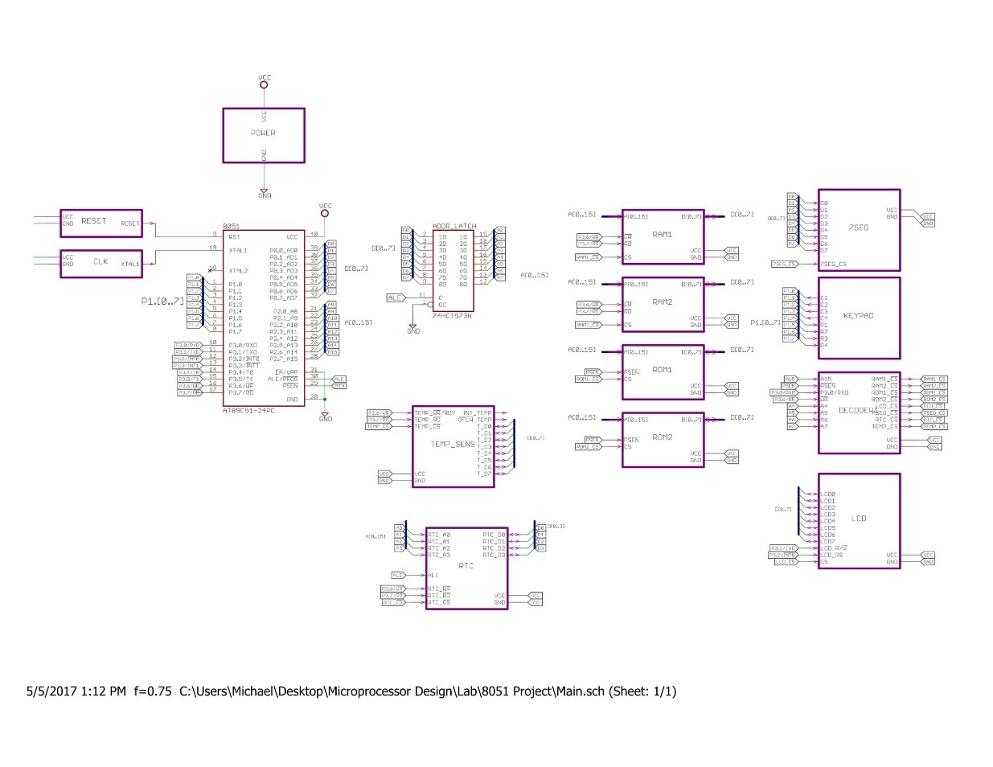

**Power**

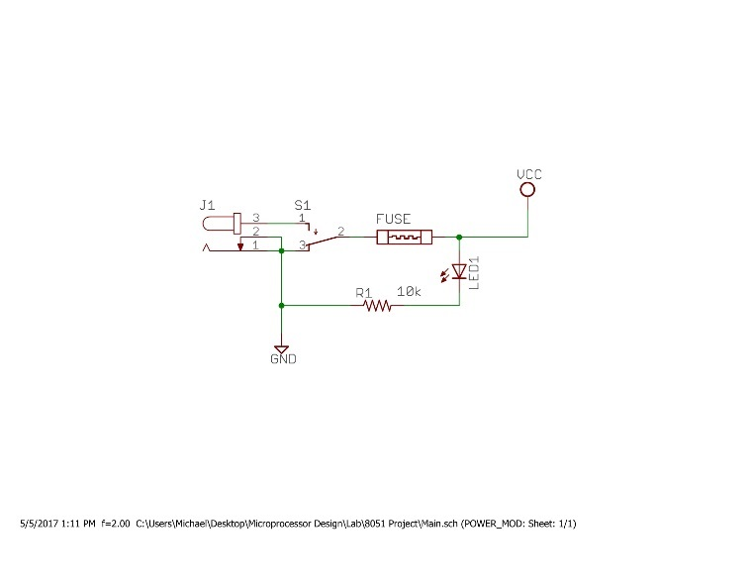

**RAM**

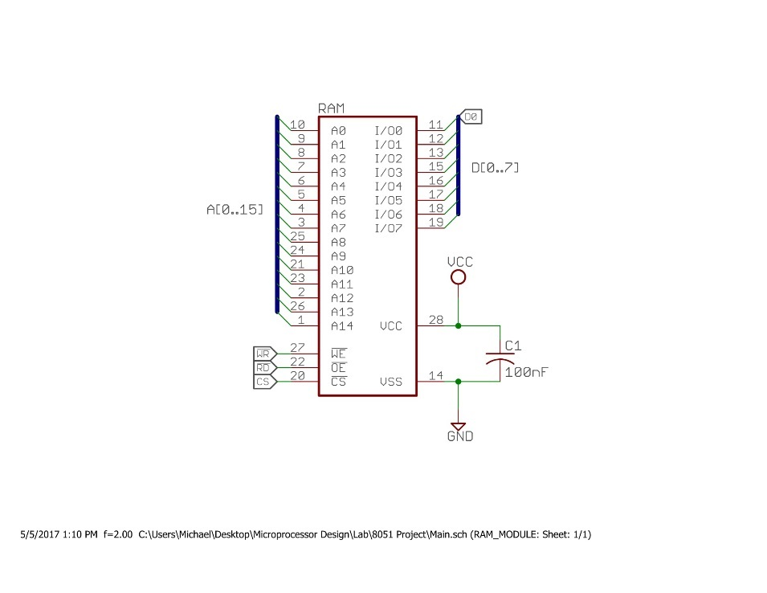

**ROM**

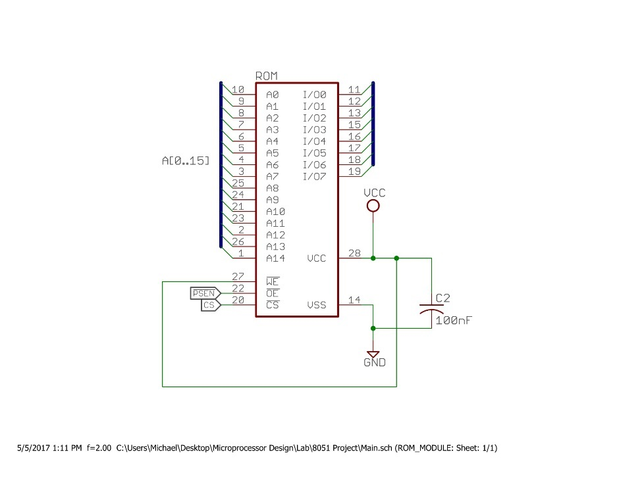

**Reset**

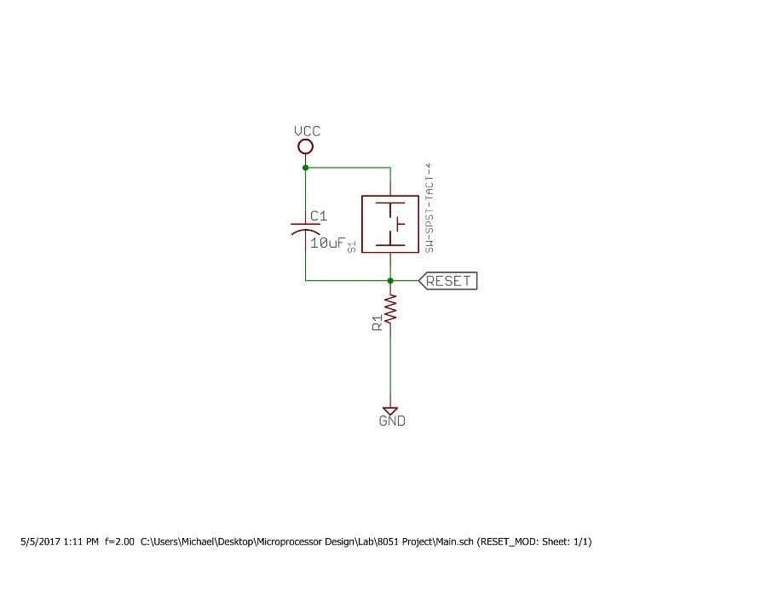

**Clock**

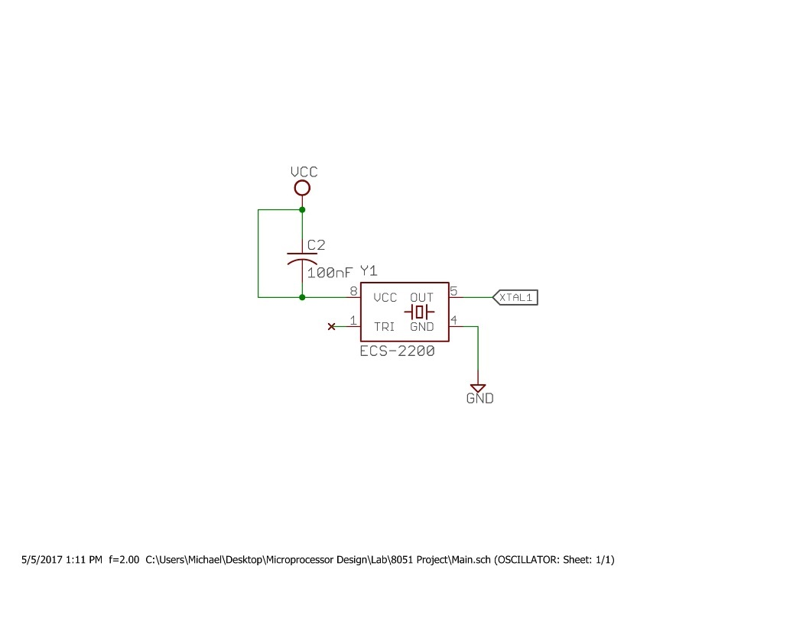

**Decoder**

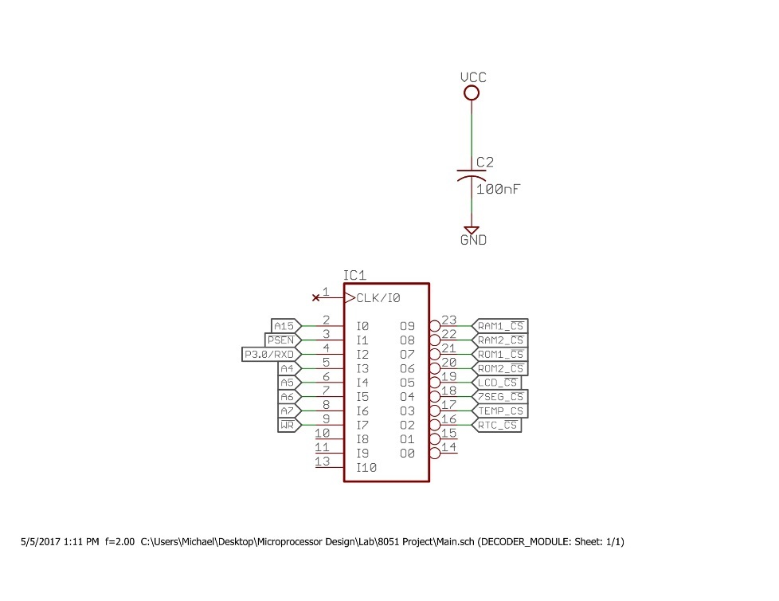

**Seven Segment**

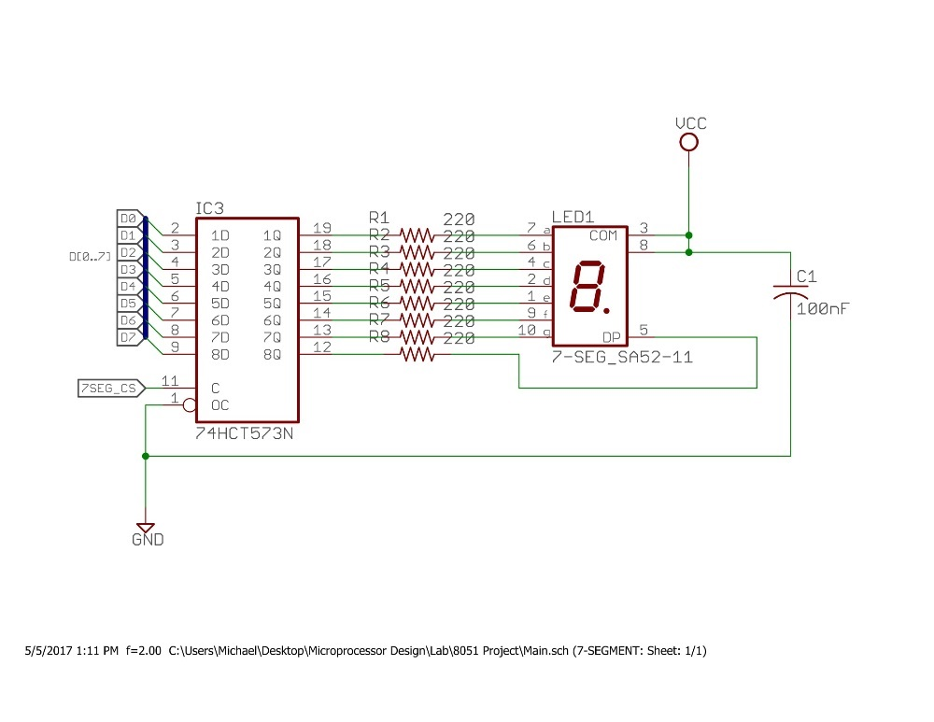

**LCD**

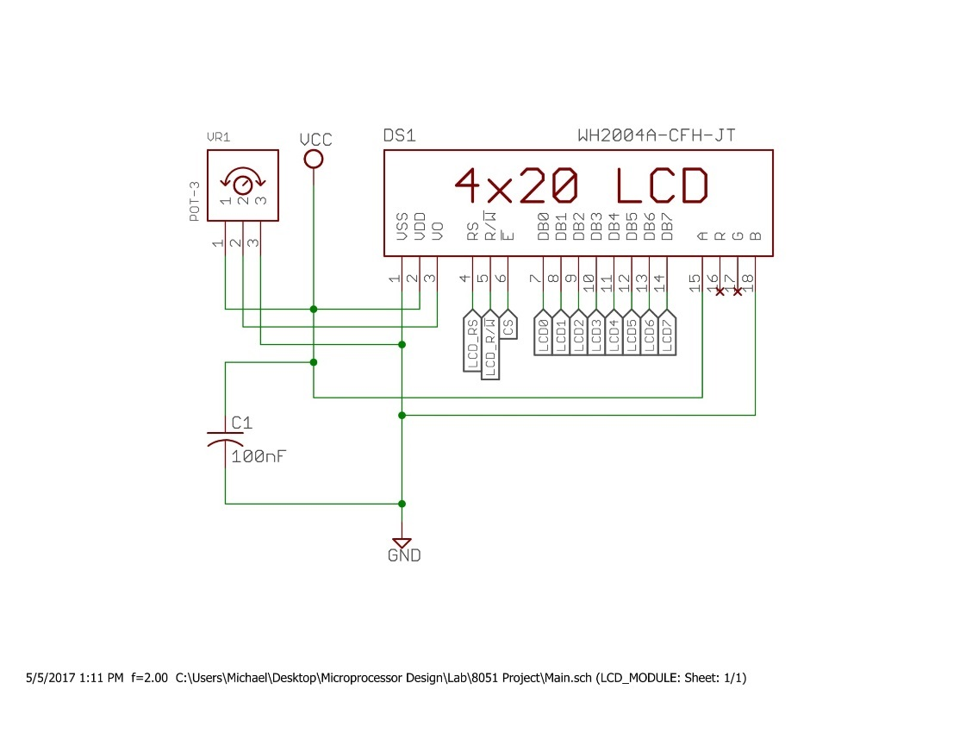

**Keypad**

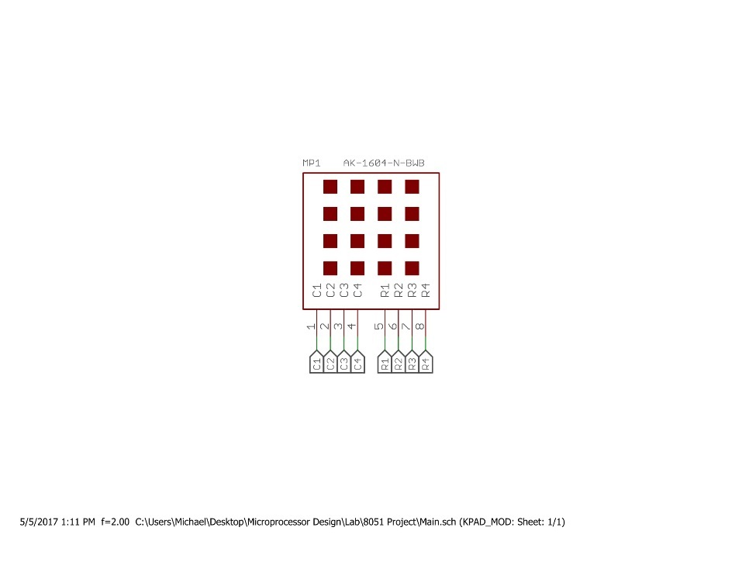

**ADC and Temperature Sensor**

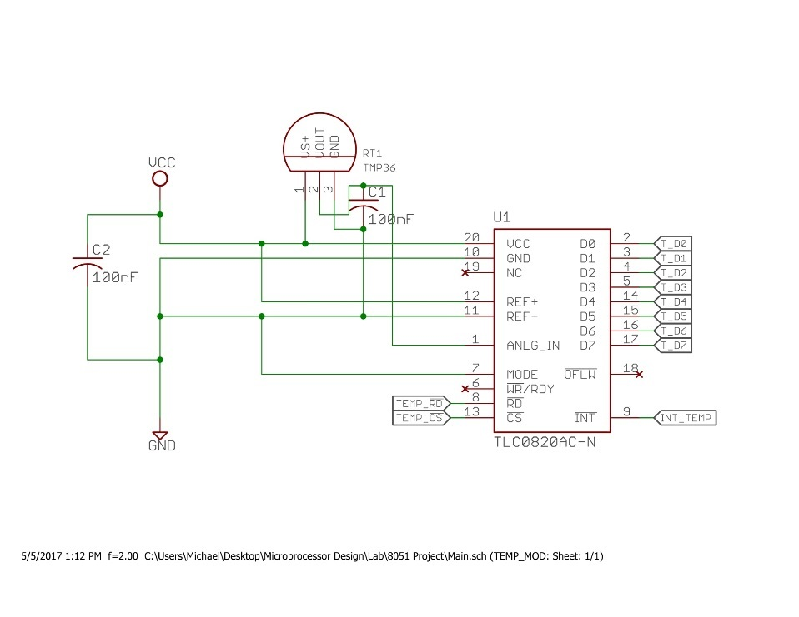

**Real Time Clock**

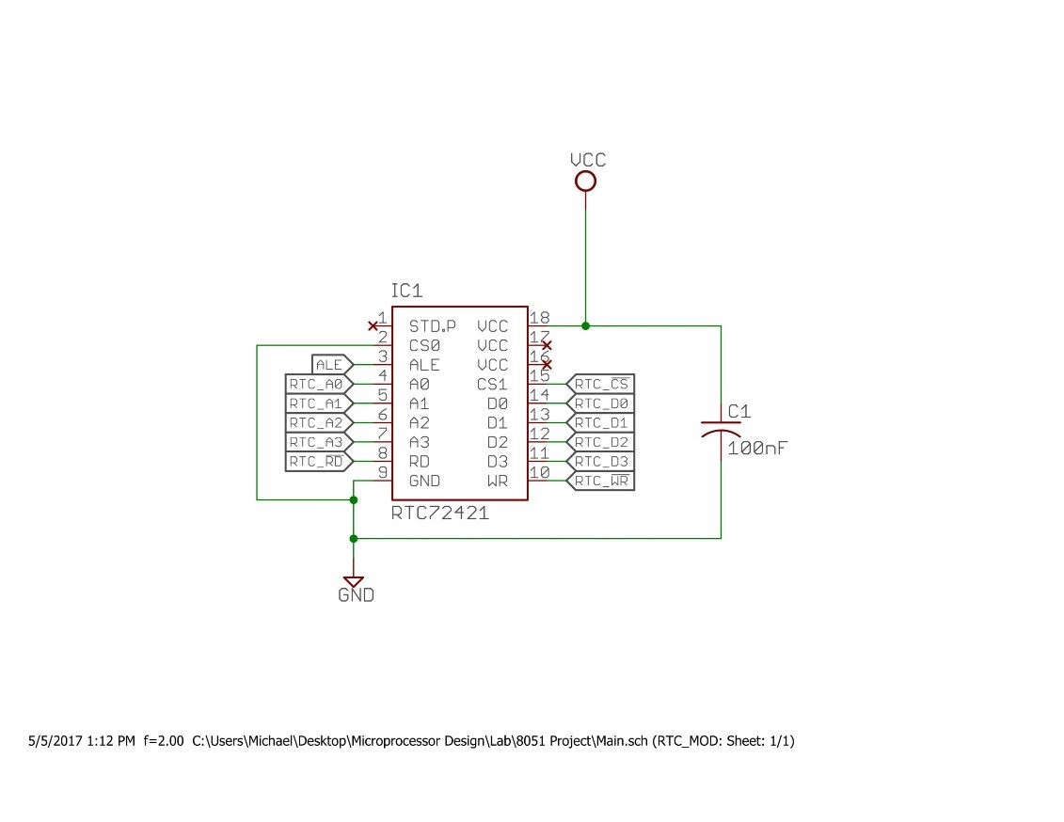

## PCB Design

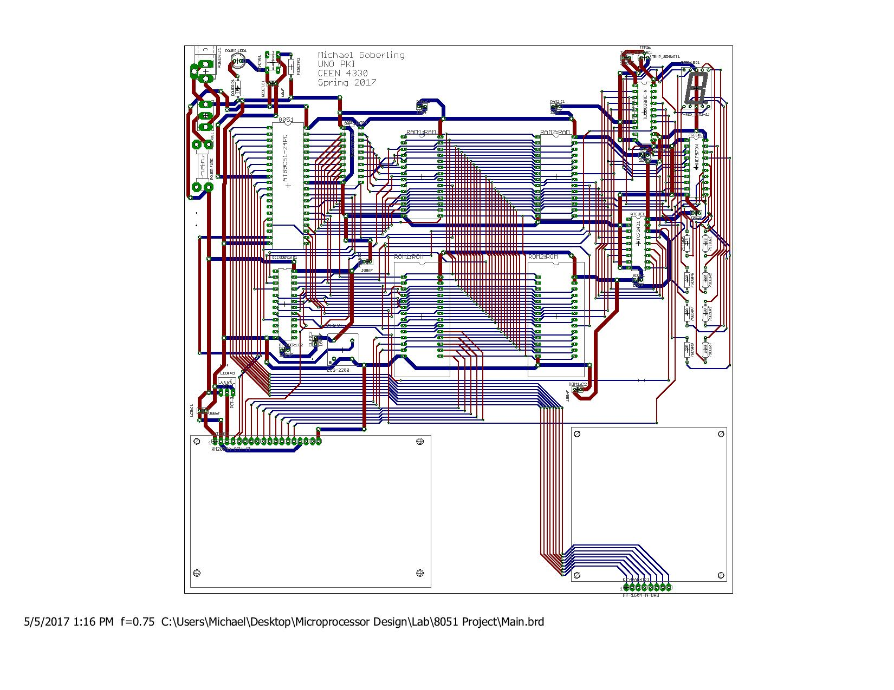

### Pictures

**Prototyping**

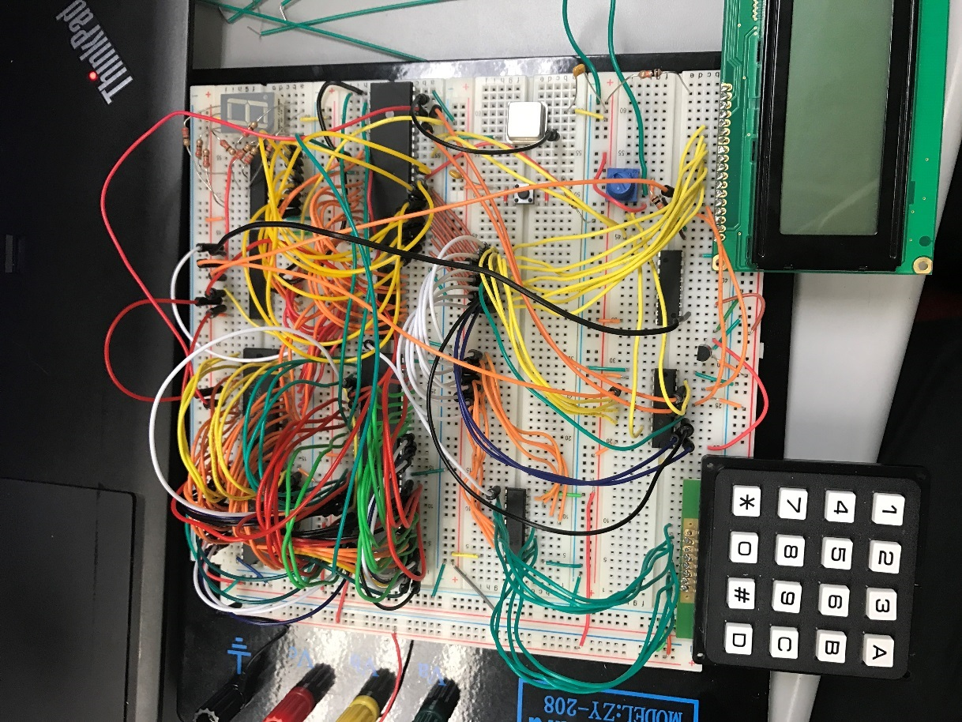

**Front**

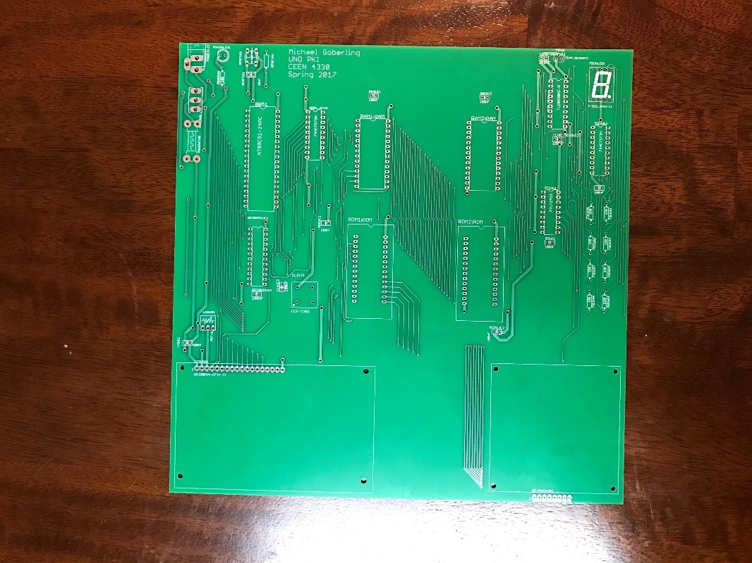

**Back**

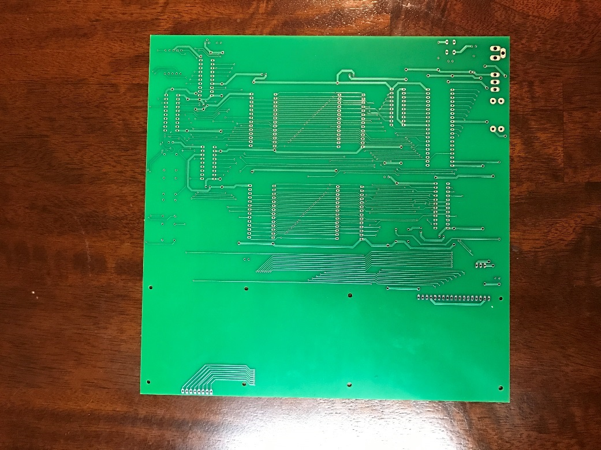

**Front of Populated Board**

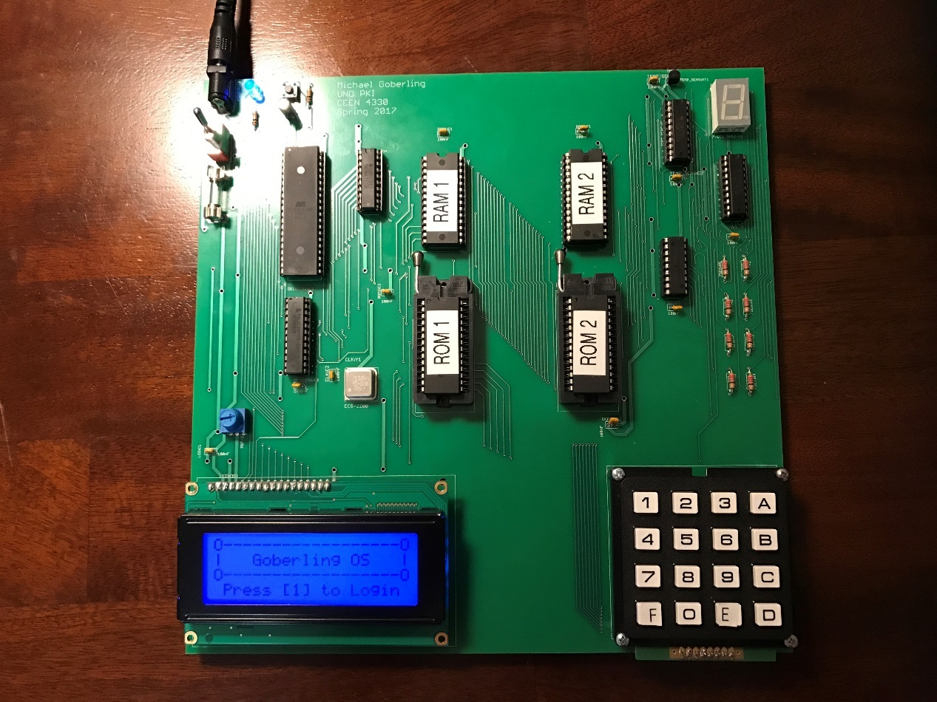

**Myself and Board**

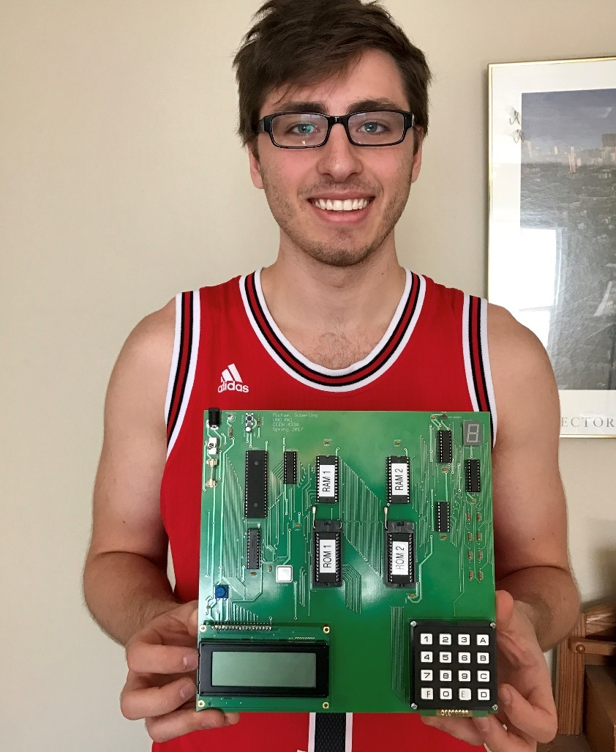

## Decoding

### Decoder Logic

**Memory Maps**

|  |  |
| --- | --- |
| RAM |  |
| CHIP 1 | FFFFh |
|  |
|  |
| 8000h |
| CHIP 2 | 7FFFh |
|  |
|  |
| 0000h |

|  |  |
| --- | --- |
| ROM |  |
| CHIP 1 | FFFFh |
|  |
|  |
| 8000h |
| CHIP 2 | 7FFFh |
|  |
|  |
| 0000h |

|  |  |  |  |
| --- | --- | --- | --- |
| I/O | | |  |
|  |  |  |  |
|  |  |  |  |
|  |  |  |  |
| LCD | | | 0080h |
| RTC | | | 0040h |
| Seven Segment Latch | | | 0020h |
| ADC w/ Temp Sensor | | | 0010h |
|  |  |  | 0000h |

**Address Map**

|  |  |  |  |  |  |  |  |
| --- | --- | --- | --- | --- | --- | --- | --- |
| Y - Signals | X - Lines | A15 | PSEN | P3.0 | A7 | A6 | A5 | A4 |
| RAM 1 (0000h - 7FFFh) | 0 | 1 | 0 | X | X | X | X |
| RAM 2 (8000h - FFFFh) | 1 | 1 | 0 | X | X | X | X |
| ROM 1 (0000h - 7FFFh) | 0 | 0 | 0 | X | X | X | X |
| ROM 2 (8000h - FFFFh) | 1 | 0 | 0 | X | X | X | X |
| ADC (0010h) | X | X | 1 | 0 | 0 | 0 | 1 |
| SEVEN SEGMENT (0020h) | X | X | 1 | 0 | 0 | 1 | 0 |
| RTC (0040h) | X | X | 1 | 0 | 1 | 0 | 0 |
| LCD (0080h) | X | X | 1 | 1 | 0 | 0 | 0 |

**Pin Declarations for PAL Device**

|  |  |  |  |
| --- | --- | --- | --- |
| Signal | PIN | Signal | PIN |
| A15 | 2 | RTC_CS | 16 |
| PSEN (input) | 3 | TEMP_CS | 17 |
| P3.0 | 4 | SEVENSEG_CS | 18 |
| A4 | 5 | LCD_CS | 19 |
| A5 | 6 | ROM2_CS | 20 |
| A6 | 7 | ROM1_CS | 21 |
| A7 | 8 | RAM2_CS | 22 |
| WR | 9 | RAM1_CS | 23 |

### Decoder Code

-- Michael Goberling

-- 8051 Decoding

-- Spring 2017

-- CEEN 4330

library ieee;

use ieee.std_logic_1164.all;

ENTITY decoder8051 IS

PORT( A15, PSEN, P3_0_RXD, A7, A6, A5, A4, WR : IN BIT;

RAM1_CS, RAM2_CS, ROM1_CS, ROM2_CS, LCD_CS, SEVENSEG_CS, TEMP_CS, RTC_CS : OUT BIT);

attribute loc : string;

attribute loc of A15 : signal is "P2";

attribute loc of PSEN : signal is "P3";

attribute loc of P3_0_RXD : signal is "P4";

attribute loc of A4 : signal is "P5";

attribute loc of A5 : signal is "P6";

attribute loc of A6 : signal is "P7";

attribute loc of A7 : signal is "P8";

attribute loc of WR : signal is "P9";

attribute loc of RAM1_CS : signal is "P23";

attribute loc of RAM2_CS : signal is "P22";

attribute loc of ROM1_CS : signal is "P21";

attribute loc of ROM2_CS : signal is "P20";

attribute loc of LCD_CS : signal is "P19";

attribute loc of SEVENSEG_CS : signal is "P18";

attribute loc of TEMP_CS : signal is "P17";

attribute loc of RTC_CS : signal is "P16";

END decoder8051;

ARCHITECTURE behavior OF decoder8051 IS

BEGIN

RAM1_CS <= (A15 OR NOT PSEN OR P3_0_RXD);

RAM2_CS <= (NOT A15 OR NOT PSEN OR P3_0_RXD);

ROM1_CS <= (A15 OR PSEN);

ROM2_CS <= (NOT A15 OR PSEN);

TEMP_CS <= (NOT P3_0_RXD OR A7 OR A6 OR A5 OR NOT A4);

SEVENSEG_CS <= (P3_0_RXD AND NOT A7 AND NOT A6 AND A5 AND NOT A4 AND NOT WR);

RTC_CS <= (P3_0_RXD AND NOT A7 AND A6 AND NOT A5 AND NOT A4);

LCD_CS <= (P3_0_RXD AND A7 AND NOT A6 AND NOT A5 AND NOT A4 AND NOT WR);

END behavior;